Table of Contents
Table of Contents 1
CHAPTER 01 - INTRODUCTION 8
1.1 Introduction 8
1.2 Background and Motivation 8
1.2.1 The SME Sector in Sri Lanka 8
1.2.2 The Regulatory Compliance Landscape 9
1.2.3 The Information Barrier Problem 9
1.3 Problem Statement 10
1.3.1 Core Problem 10
1.3.2 Sub-Problems 10
1.4 Research Questions 11
1.4.1 Main Research Question 11
1.4.2 Module-Specific Research Questions 11
1.5 Aim and Objectives 11
1.5.1 Aim 11
1.5.2 Objectives 11
1.6 Scope and Limitations 12
1.7 Stakeholders 13
1.8 Proposed Solution Overview 13
1.9 Summary 14
CHAPTER 02 - LITERATURE REVIEW 14
2.1 Introduction 14
2.2 SME Regulatory Compliance in Developing Economies 14
2.3 Information Asymmetry and Compliance Behavior 15
2.4 Regulatory Change Communication and Awareness Lag 16
2.5 Compliance Knowledge Gaps and Guidance Accuracy 16
2.6 Compliance Risk Prediction Using Public Data 17
2.7 Misinformation Detection in Regulatory and Financial Domains 18
2.8 Multilingual NLP for Low-Resource Languages 18
2.9 Retrieval-Augmented Generation for Domain-Specific QA 19
2.10 Comparative Analysis of Existing Approaches 20
2.11 Identified Research Gap 20
2.12 Summary 21
CHAPTER 03 - TECHNOLOGY ADAPTED 23
3.1 Introduction 23
3.2 Common Technologies 23
3.2.1 Data Acquisition 23
3.2.2 Natural Language Processing 24
3.2.3 Application Stack 24
3.2.4 Annotation and Statistical Tooling 25
3.3 Module 1 — Regulatory Change Awareness Gap 26
3.3.1 Module-Specific Requirements 26
3.3.2 Common Technologies Inherited 26
3.3.3 Module 1 — Specific Technologies 27
3.4 Module 2 — Compliance Knowledge Accuracy Gap 28
3.4.1 Module-Specific Requirements 28
3.4.2 Common Technologies Inherited 28
3.4.3 Module 2 — Specific Technologies 29
3.4.4 Module 2 Deliverable System 31
3.5 Module 3 — Compliance Risk Invisibility 32
3.5.1 Module-Specific Requirements 32
3.5.2 Common Technologies Inherited 32
3.5.3 Module 3 — Specific Technologies 33
3.5.4 Module 3 Deliverable System 34
3.6 Module 4 — Regulatory Misinformation Spread 35
3.6.1 Module-Specific Requirements 35
3.6.2 Common Technologies Inherited 35
3.6.3 Module 4 — Specific Technologies 36
3.6.4 Module 4 Deliverable System 38
3.7 Cross-Module Dependency Map 38
3.8 Summary 39
CHAPTER 04 - OUR APPROACH 40
4.1 Introduction 40
4.2 Conceptual Framework 40
4.3 Module 1 - Regulatory Change Awareness Gap 41
4.3.1 Users, Inputs, Outputs, Process 41
4.3.2 Methodology 41
4.4 Module 2 - Compliance Knowledge Accuracy Gap 42
4.4.1 Users, Inputs, Outputs, Process 42
4.4.2 Methodology 42
4.5 Module 3 - Compliance Risk Invisibility 43
4.5.1 Users, Inputs, Outputs, Process 43
4.5.2 Methodology 43
4.6 Module 4 - Regulatory Misinformation Spread 44
4.6.1 Users, Inputs, Outputs, Process 44
4.6.2 Methodology 44
4.7 Integration - The Unified Platform 45
4.8 Evaluation Strategy 45
4.9 Summary 46
CHAPTER 05 - ANALYSIS AND DESIGN 47
5.1 Introduction 47
5.2 Requirements Analysis 47
5.2.1 Functional Requirements 47
5.2.2 Non-Functional Requirements 48
5.3 High-Level System Architecture 48
5.4 Module-Level Design 49
5.4.1 Module 1 Pipeline 49
5.4.2 Module 2 Pipeline 51
5.4.3 Module 3 Pipeline 51
5.4.4 Module 4 Pipeline 52
5.5 Data Flow Diagrams 53
5.6 UML Diagrams 54
5.6.1 Domain Class Diagram 54
5.6.2 Sequence Diagram — End-to-End Compliance Question 55
5.7 Database Design 55
5.8 User Interface Design 57
5.9 Inter-Module Communication Design 57
5.10 Summary 58
CHAPTER 06 - IMPLEMENTATION 58
6.1 Introduction 58
6.2 Development Environment and Setup 59
6.3 Module 1 Implementation Progress 59
6.3.1 Gazette Scraper 59
6.3.2 Regulatory Change Classifier 60
6.3.3 Lag Computation 60
6.4 Module 2 Implementation Progress 61
6.4.1 Knowledge Base Construction 61
6.4.2 RAG Pipeline 61
6.4.3 Compliance Knowledge Survey 61
6.5 Module 3 Implementation Progress 61
6.5.1 Dataset Assembly 61
6.5.2 Model Training and Comparison 61
6.5.3 Explainability Layer 61
6.6 Module 4 Implementation Progress 61
6.6.1 Social Media Collection 61
6.6.2 Annotation Workflow 61
6.6.3 Misinformation Classifier 61
6.7 Platform Integration Progress 61
6.8 Pseudocode and Code Segments 61
6.9 Summary 61
CHAPTER 07 - DISCUSSION 61
7.1 Introduction 61
7.2 Preliminary Results and Observations 61
7.3 Comparison with Similar Works 61
7.4 Limitations and Risks 62
7.4.1 Data Availability Risks 62
7.4.2 Survey Response Risks 62
7.4.3 Model Generalization Risks 62
7.5 Ethical Considerations 62
7.5.1 Privacy and Anonymisation 62
7.5.2 Bias and Fairness 62
7.5.3 Security and Data Handling 62
7.5.4 Ethics Approval Status 62
7.6 Plan for Evaluation 62
7.6.1 Evaluation Metrics per Module 62
7.6.2 Validation against Research Findings 62
7.7 Future Work 62
7.8 Summary 62
REFERENCES 62
Appendix A - Individual's Contribution to the Project 68
A.1 215075J - Mohamed M.R.I 68
A.2 215007F - Ahamadh M.S.A 68
A.3 215008J - Ahamed T.I 68
A.4 215019T - Cader Z.R 68
Appendix B - Survey Instruments 68
Appendix C - Sample Annotated Data 68
Appendix D - Code Listings and Algorithms 68
Appendix E - Detailed Architecture Diagrams 68
Appendix F - Ethics Approval Documentation 68

CHAPTER 01 - INTRODUCTION

1.1 Introduction
Small and Medium Enterprises (SMEs) form the backbone of the Sri Lankan economy, contributing significantly to GDP, employment generation, and entrepreneurial innovation [1], [2]. Despite their economic importance, a persistent and largely unexamined challenge undermines their sustainability: regulatory non-compliance driven not by intent, but by information failure. Sri Lankan SMEs operate within a complex regulatory environment governed by multiple authorities, including the Inland Revenue Department (IRD), the Employees' Provident Fund (EPF), the Employees' Trust Fund (ETF), and the eRegistrar of Companies (eROC). Each of these institutions issues regulations, amendments, and procedural updates that SMEs are legally obligated to follow [3].
However, observation and preliminary inquiry suggest that the average SME owner in Sri Lanka does not fail at compliance because they wish to evade regulation. They fail because the right information does not reach them at the right time, in the right language, with the right level of accuracy. Regulatory changes published in the Government Gazette take weeks or months to reach SMEs. Guidance received from accountants, social media groups, and online forums is often inaccurate [4]. Official documents are predominantly in English, while most SME owners conduct business in Sinhala or Tamil [5]. By the time a penalty notice arrives, the owner often did not know a violation was occurring.
This research proposes a structured, empirical investigation into the information barriers that drive regulatory non-compliance among Sri Lankan SMEs. Rather than assuming the problem and building a tool, this study measures each barrier first - quantifying information lag, knowledge gaps, risk invisibility, and misinformation spread - and then constructs a unified, AI-powered platform validated against those measurements. The work contributes four novel datasets and four measurable findings to the body of knowledge on SME compliance in developing economies.
1.2 Background and Motivation

1.2.1 The SME Sector in Sri Lanka
SMEs constitute over 75 percent of all enterprises in Sri Lanka and are widely recognized as a critical engine of economic development [1], [2]. They generate a substantial share of national employment, approximately 45 percent of the workforce, contribute around 52 percent to GDP, and play a vital role in regional economic balance by sustaining livelihoods outside major urban centers [1], [6]. The sector spans a diverse range of industries, including manufacturing, retail, agriculture, tourism, services, and construction [2]. SMEs are typically owner-managed, operate with limited administrative staff, and rarely possess in-house legal or compliance expertise [7].
This structural reality places Sri Lankan SMEs in a position of asymmetric vulnerability. Unlike large corporations, which maintain dedicated tax, legal, and compliance departments, SMEs depend on external advisors, informal networks, and self-research for regulatory understanding [4], [7]. The economic crisis of 2022 and subsequent tax reforms - including the introduction of the Social Security Contribution Levy (SSCL) under Act No. 25 of 2022 and revisions to the VAT regime - have intensified the regulatory burden on this sector [8], [9]. Yet the support infrastructure for navigating this burden has not evolved correspondingly.

1.2.2 The Regulatory Compliance Landscape
Regulatory compliance for a Sri Lankan SME involves obligations across multiple, fragmented authorities. The Inland Revenue Department administers Income Tax, Value Added Tax (VAT), Withholding Tax, and the Social Security Contribution Levy [3], [9]. The Employees' Provident Fund and Employees' Trust Fund regulate mandatory contributions for employee welfare. The e-Registrar of Companies governs incorporation, annual returns, and corporate filings. Sector-specific regulators add further layers - the Board of Investment, the Central Environmental Authority, the Consumer Affairs Authority, and others. Such fragmentation, common across developing economies, has been identified as a significant driver of compliance cost and complexity for SMEs [10].
Critically, regulatory changes in Sri Lanka are formally communicated through the Government Gazette, a publication that is publicly available but not actively pushed to affected businesses. There is no centralized SME-facing notification system. Updates to tax rates, filing deadlines, contribution thresholds, and procedural requirements may be published with little advance warning [8], leaving SMEs to discover changes through accountants, news media, social media, or - most commonly - penalty notices issued after the fact.

1.2.3 The Information Barrier Problem
The central motivation for this research is a recurring observation: Sri Lankan SMEs want to comply, but cannot, because of four interlocking information barriers.
The first barrier is timing. Regulatory changes do not reach SMEs quickly enough to act. The lag between gazette publication and actual SME awareness has never been measured for Sri Lanka, but anecdotal evidence and regional studies suggest it is significant [11].
The second barrier is accuracy. The compliance guidance SMEs receive - from accountants, peers, Facebook groups, and forums - is frequently incorrect or outdated [4]. The accuracy rate of these informal channels has never been benchmarked.
The third barrier is visibility. SMEs cannot see their own compliance risk until a violation occurs. There is no early warning system, and no study has identified which SME characteristics most strongly predict compliance failure in the Sri Lankan context [12].
The fourth barrier is language and integrity of information. Misinformation about tax regulations spreads rapidly through Sinhala and Tamil social media networks [13], [14]. The prevalence and virality of this misinformation, relative to accurate guidance, has not been quantified.
Together, these four barriers form an invisible compliance trap. This research seeks to make the trap visible - and then to dismantle it.

1.3 Problem Statement

1.3.1 Core Problem
Sri Lankan SMEs experience high rates of regulatory non-compliance not because of unwillingness, but because critical regulatory information fails to reach them in the right time, in the right form, in the right language, and with the right accuracy [4], [10]. Despite the economic significance of the sector [1], [2], no systematic, data-driven study has measured the information barriers that produce this outcome, and no integrated solution exists that addresses all four barriers in a unified manner.

1.3.2 Sub-Problems
The core problem decomposes into four investigable sub-problems, each corresponding to a distinct information barrier:
Sub-Problem 1 - The Awareness Gap. Regulatory changes are published in the Government Gazette but reach SMEs only after a significant and unmeasured delay. The duration of this lag, the channels that bridge it, and the change-types most affected have never been empirically established [11].
Sub-Problem 2 - The Knowledge Gap. The compliance guidance circulating among SMEs - through accountants, peers, and online sources - varies widely in accuracy [4]. The gap between official regulatory requirements and actual SME understanding has never been quantified, nor has the accuracy of informal guidance channels been benchmarked against verified sources.
Sub-Problem 3 - The Risk Invisibility Gap. SMEs lack any mechanism for predicting their own compliance failure before it materializes. The characteristics, behaviors, and contextual factors that predict non-compliance in the Sri Lankan SME context have not been studied, leaving owners blind to risk until penalties are issued [12], [15].
Sub-Problem 4 - The Misinformation Gap. Regulation misinformation spreads through Sri Lankan SME networks, particularly via WhatsApp, Facebook, and online forums [13], [14]. The prevalence of this misinformation, its rate of spread relative to accurate content, and the linguistic features that make it viral have never been measured.

1.4 Research Questions

1.4.1 Main Research Question
What are the information barriers that drive regulatory non-compliance among Sri Lankan SMEs, and how can they be systematically identified and addressed through a unified, AI-powered platform?
This question is genuinely unanswered in the existing literature, focuses on a real-world problem rather than on the performance of AI systems in the abstract, and requires investigation across all four research modules to be answered comprehensively. Its findings are generalizable to other developing economies that share Sri Lanka's regulatory fragmentation [10], [11].

1.4.2 Module-Specific Research Questions
To address the main question, four module-specific research questions guide the investigation:
RQ1 - Awareness Gap (Module 1): Are regulatory changes reaching Sri Lankan SMEs in time to act, and what is the information lag between Gazette publication and SME awareness?
RQ2 - Knowledge Gap (Module 2): How accurate is the compliance guidance that Sri Lankan SMEs receive, and what is the gap between official regulatory requirements and what SMEs actually understand?
RQ3 - Risk Gap (Module 3): Which characteristics of Sri Lankan SMEs predict compliance failure, and can these signals be detected before a violation occurs?
RQ4 - Misinformation Gap (Module 4): How significantly does regulation misinformation spread through Sri Lankan SME networks, and what makes certain misinformation more viral than accurate official guidance?
1.5 Aim and Objectives

1.5.1 Aim
The aim of this research is to empirically investigate the information barriers that drive regulatory non-compliance among Sri Lankan SMEs and to design, develop, and validate a unified, AI-powered SME Regulatory Intelligence Platform that delivers the right information, to the right SME, at the right time, in the right language - measurably reducing each identified barrier.

1.5.2 Objectives
The aim is achieved through the following objectives:
Objective 1 - Measure the Awareness Gap. To quantify the information lag at every stage from Gazette publication to SME awareness, identify the most effective communication channels, and develop an automated gazette-monitoring and alert system validated against measured awareness times [16].
Objective 2 - Measure the Knowledge Gap. To construct a verified ground-truth knowledge base of Sri Lankan compliance requirements, benchmark SME compliance knowledge against this ground truth, measure the accuracy of informal guidance channels, and develop a Retrieval-Augmented Generation (RAG) multilingual compliance assistant [17], [18] validated against the measured baseline using standard frameworks such as RAGAS.
Objective 3 - Measure the Risk Gap. To identify the SME characteristics and behavioral signals that most strongly predict compliance failure, evaluate machine learning approaches under data-scarce conditions, and develop an explainable early-warning risk-scoring system using SHAP-based interpretability [12], [15] validated retrospectively against historical violation records.
Objective 4 - Measure the Misinformation Gap. To quantify the prevalence, spread, and linguistic characteristics of regulation misinformation in Sri Lankan SME networks, construct an annotated misinformation corpus using cross-lingual transformer models such as XLM-R [5], [19], and develop a real-time claim verification interface validated against the corpus.
Objective 5 - Integration and Contribution. To integrate the four module outputs into a single platform, demonstrate operational interoperability between modules, and deliver four novel datasets and four measurable research findings as scholarly contributions.

1.6 Scope and Limitations
Scope. The research is scoped to registered Small and Medium Enterprises operating within Sri Lanka, focusing on regulatory obligations administered by the IRD, EPF, ETF, and eROC [3]. Regulatory changes considered span the period 2018 to 2026, providing both pre- and post-economic-crisis coverage [8]. The research covers content in English, Sinhala, and Tamil [5]. The platform is developed as a research prototype, not a production-grade commercial deployment.
Limitations. Several limitations are explicitly acknowledged. First, no private enterprise data is collected; the study relies entirely on publicly available data, ethically administered surveys, and synthetically generated data calibrated to public statistics - meaning some findings are constrained by the granularity of public records. Second, survey-based measurements depend on respondent self-reporting and are subject to recall and selection bias, mitigated through sampling protocols but not eliminated. Third, social media data collection is constrained by platform API limits and terms of service, particularly on Facebook and X [13]. Fourth, translation of Sinhala and Tamil content using machine translation introduces possible semantic drift, which is mitigated by manual verification on a sample basis [5]. Fifth, the validation period is limited to the duration of the academic project, which restricts longitudinal observation of platform impact.

1.7 Stakeholders
The research engages and serves multiple stakeholder groups. SME owners and finance staff are the primary beneficiaries; they will use the platform to receive timely, accurate, and language-appropriate compliance guidance. Regulatory authorities - including the IRD, EPF, ETF, and eROC - benefit from improved voluntary compliance and are potential institutional partners for deployment [3]. Industry bodies such as the Ceylon Chamber of Commerce, the National Enterprise Development Authority (NEDA), and sector-specific chambers serve both as channels for survey distribution and as future dissemination partners [1]. Accountants and tax practitioners are simultaneously a subject of study (as a guidance channel whose accuracy is measured) and potential users of the verified knowledge base [4]. The academic community benefits from the four novel datasets and the generalizable methodologies released as research outputs. The Faculty of Information Technology at the University of Moratuwa and the project supervisor provide academic oversight, evaluation, and intellectual guidance.

1.8 Proposed Solution Overview
The proposed solution is the SME Regulatory Intelligence Platform, a unified, AI-powered system in which each component is empirically grounded in a measured information barrier rather than in assumption. The platform draws on the Regulatory Technology (RegTech) paradigm, which applies AI, NLP, and data analytics to streamline compliance [16], [20], adapted here for the data-scarce, multilingual context of a developing economy.
The platform integrates four interoperating modules. The Regulatory Change Monitor continuously scrapes the Government Gazette and official portals, classifies changes using a fine-tuned multilingual NLP model based on XLM-R [5], [19], and pushes timely alerts to registered SMEs in their preferred language. The Compliance Guidance Assistant is a RAG-based question-answering system [17], [18] grounded strictly in a verified knowledge base of official regulatory documents, providing accurate multilingual responses with citations to source authorities. The Compliance Risk Predictor assigns each SME an explainable risk score using a machine learning model trained on public violation records, survey data, and synthetic data, with SHAP-based explanations [12], [15] indicating the contributing risk factors. The Claim Verification Interface allows users to submit any compliance claim received from any source - WhatsApp message, Facebook post, accountant's advice - and receive an instant verdict cross-checked against the verified knowledge base [13], [14].
The four modules share a common verified knowledge base and trigger one another in response to real-world events. When the monitor detects a new regulation, the knowledge base updates, risk scores are recomputed, and the claim verifier begins evaluating new claims against the updated rules. The platform is delivered through a React.js frontend and a FastAPI backend, with PostgreSQL and ChromaDB providing structured and vector storage respectively.
Each module is validated not by user satisfaction surveys alone, but by direct comparison against the empirical baselines established in its own research investigation - closing the loop between the problem measured and the solution delivered.

1.9 Summary
This chapter introduced the central concern of the research: that Sri Lankan SMEs fail at regulatory compliance not from intent but from information failure, and that this failure operates through four distinct, measurable barriers - awareness lag, knowledge inaccuracy, risk invisibility, and misinformation spread. The chapter articulated the core problem and its four sub-problems, formulated the main research question and its four module-specific counterparts, defined the aim and five supporting objectives, and bounded the scope and limitations of the study. It identified the stakeholders who motivate, participate in, and benefit from the work, and outlined the SME Regulatory Intelligence Platform as the unified solution whose components are each grounded in an empirically measured barrier. Finally, it presented the structure of the dissertation that follows. The next chapter establishes the scholarly context for these contributions through a critical review of the relevant literature.

CHAPTER 02 - LITERATURE REVIEW

2.1 Introduction
This chapter establishes the scholarly foundation for the present research by critically reviewing the literature across the seven domains that intersect at the research problem: SME regulatory compliance in developing economies, information asymmetry as a theoretical lens, regulatory communication and awareness lag, compliance knowledge gaps, machine-learning-based compliance risk prediction, misinformation detection in financial and regulatory contexts, multilingual NLP for low-resource languages, and retrieval-augmented generation (RAG) for domain-specific question answering. Each section examines what has been studied, identifies the limits of existing work, and isolates the gap that this study fills. The chapter concludes with a comparative analysis of existing approaches.

2.2 SME Regulatory Compliance in Developing Economies
A substantial body of research has examined the determinants of tax compliance behaviour among Small and Medium Enterprises (SMEs) in developing economies. Musiimenta et al. [22] established, in the Ugandan context, that knowledge requirements, tax complexity, and compliance costs significantly shape SME compliance behaviour, finding that SMEs with greater procedural understanding exhibit higher compliance rates. Similar results have been replicated across Indonesia, Botswana, Ethiopia, and Jordan: tax literacy, perceptions of fairness, and the quality of service delivery from tax authorities consistently emerge as the strongest predictors of voluntary compliance [23], [24], [25]. The slippery-slope framework proposed by Kirchler et al. [25] further argues that voluntary compliance depends on trust in authorities, while enforced compliance depends on authority power, and that the two reinforce one another.
While these studies firmly establish that information and understanding are the central levers of SME compliance, none explicitly measure the upstream information environment in which SMEs operate. They treat tax literacy as an attribute of the SME owner, not as a consequence of the regulatory communication channels available to them. The research consistently identifies that SMEs in developing economies struggle with disproportionate compliance costs and limited in-house capacity [7], [4], yet the question of how regulatory information actually flows from authorities to SMEs - and where it breaks down - remains unaddressed. The Sri Lankan literature in particular contains no systematic study that measures the channels, lag, or accuracy of regulatory information delivery for SMEs.

2.3 Information Asymmetry and Compliance Behavior
The theoretical framing for this research draws on the foundational work of Akerlof on information asymmetry [26]. In The Market for Lemons, Akerlof demonstrated how an imbalance of information between transacting parties can degrade market outcomes to the point of collapse. The framework has since been extended to a wide range of contexts, including pharmaceuticals [27], insurance, education, and financial markets, and has informed the design of regulatory signalling mechanisms intended to mitigate asymmetry [28].
Within the SME compliance literature, information asymmetry has been invoked primarily in the financial context - to explain why SMEs face restricted access to formal credit when lenders cannot verify their performance [21], [29]. ESG disclosure literature similarly argues that improved information disclosure reduces information asymmetry between SMEs and external stakeholders, lowering capital costs and improving compliance posture [29]. However, the asymmetry that this research investigates is of a different and largely underexplored type: the asymmetry between regulator and regulated. When a state publishes new regulations and the affected SMEs do not learn of them in time, in their language, or with accuracy, the asymmetry is not between a buyer and a seller but between a rule-maker and a rule-follower. This form of regulatory information asymmetry has been theoretically gestured at [10], [16] but never empirically measured for a developing-economy SME population. The present study positions itself directly within this gap.

2.4 Regulatory Change Communication and Awareness Lag
The Regulatory Technology (RegTech) literature has emerged in the past decade as the primary scholarly response to growing compliance complexity. Arner et al. [11] traced the post-2008 emergence of RegTech as a distinct subfield, motivated by the observation that compliance teams in large institutions spend significant resources continuously screening and interpreting regulatory updates. McKinsey's survey of the field [16] characterises RegTech as software that automates and improves how organisations manage compliance, monitor risk, and report to regulators, with each update reflecting current regulatory requirements. Butler and O'Brien [20] further demonstrated how semantic technologies and natural language processing can produce machine-readable regulatory taxonomies, enabling the automated propagation of regulatory change.
Recent advances apply transformer-based NLP directly to regulatory monitoring. Banerjee [30] describes a near-real-time regulatory awareness pipeline in which PDFs are ingested, legal entities extracted using fine-tuned transformers, and updates semantically linked to prior rules. Similar pipelines have been deployed in financial reporting [31] and in U.S. federal compliance contexts [32], with reported outcomes including a 75% faster turnaround for assessing regulatory impacts. Specialized work on regulatory question answering (RegNLP) has further explored the use of transformer architectures to extract obligations from legal contracts and EU/UK legislation [33].
The clear limitation of this literature is its near-exclusive focus on large, well-resourced institutions in advanced economies. RegTech is built and benchmarked for global banks managing GDPR or MiFID II compliance, not for an SME owner in Sri Lanka attempting to track gazette amendments. Crucially, none of these systems has been evaluated against a measured baseline of how long it actually takes for a regulatory change to reach the affected community. The lag from gazette publication to SME awareness is implicitly assumed to be a problem worth solving, but it has never been quantified for any developing-economy population. This research directly measures that lag.

2.5 Compliance Knowledge Gaps and Guidance Accuracy
The hypothesis that SME compliance failures stem largely from gaps in compliance knowledge has been empirically supported across many jurisdictions. Studies in Indonesia, Botswana, and Uganda consistently show that SMEs with higher tax literacy demonstrate measurably higher compliance [22], [23], [24]. Yet these studies measure knowledge as a self-reported attribute of the owner - typically through Likert-scale questions - rather than benchmarking actual SME knowledge against verified ground truth. They establish that knowledge matters, but they do not quantify the gap between what SMEs know and what regulations actually require.
A second strand of literature examines the sources SMEs consult for compliance guidance. SMEs in developing economies depend disproportionately on accountants, peers, and informal networks because they lack in-house compliance expertise [7], [4]. The accuracy of these informal channels has been subject to almost no empirical scrutiny. While the public-health literature has produced a rich body of work on informal health information accuracy on social media [34], [35], no equivalent body of work exists for regulatory information aimed at SMEs. The closest analogue is the broader misinformation literature reviewed in Section 2.7, but that work focuses on viral political and health misinformation, not on routine regulatory guidance.
Recent advances in retrieval-augmented generation (Section 2.9) provide a technical pathway for grounding compliance guidance in verified official sources, but the empirical baseline against which such systems should be evaluated - namely, the actual accuracy of currently available informal guidance - has not been established. This study constructs both the verified ground truth and the empirical baseline.

2.6 Compliance Risk Prediction Using Public Data
Machine learning for credit and compliance risk prediction has matured into a well-developed research area. Bussmann et al. [12] proposed an explainable AI model for credit risk that applies correlation networks to Shapley values, demonstrating on a dataset of 15,000 SMEs that risk profiles can be grouped according to similar financial characteristics. Subsequent work has applied SHAP- and LIME-based interpretability to credit-default prediction in Italian SMEs [36], to credit card fraud detection [37], and to broader financial decision support [38]. Lundberg and Lee's foundational SHAP framework [15] has become the de facto standard for explaining ML predictions in regulated financial domains, where regulators increasingly require auditability of automated decisions [39].
Two methodological challenges dominate this literature. The first is class imbalance: compliance violations and frauds are statistically rare, and naïve classifiers default to predicting the majority "compliant" class. The Synthetic Minority Over-sampling Technique (SMOTE) introduced by Chawla et al. [40] remains the most widely used remedy, with extensive empirical validation across credit-card fraud [41], [42], banking transactions, and healthcare. The second challenge is data availability: most published risk-prediction models rely on proprietary financial data from banks or fintech firms, making them difficult to replicate in jurisdictions without such data infrastructure.
For SMEs in developing economies - and Sri Lanka in particular - neither rich proprietary datasets nor large historical violation corpora are publicly available. The literature offers no model for compliance risk prediction that operates entirely on public data sources, calibrated through synthetic generation against population statistics. The closest parallel work uses synthetic data libraries such as CTGAN to simulate financial datasets, but always in addition to a substantial real dataset. This research designs a methodology specifically for the data-scarce, public-only setting characteristic of developing-economy SME populations.

2.7 Misinformation Detection in Regulatory and Financial Domains
The detection of misinformation on social media has produced an extensive literature centred on health misinformation (especially during COVID-19) and political misinformation. Balakrishnan et al. [14], in a systematic review of misinformation sharing on social media, identified WhatsApp and Facebook as the platforms most heavily implicated in the spread of rumours, with anxiety, political affiliation, and conspiracy ideation among the strongest predictors of sharing behaviour. Nobre, Ferreira, and Almeida [13] provided detailed network-oriented analysis of misinformation propagation on WhatsApp, demonstrating that despite WhatsApp's ostensibly private structure, an underlying network connects users across groups in ways that systematically favour information dissemination - and that misinformation campaigns leverage this structure for significant social, political, and economic effect.
Technically, misinformation detection has converged on transformer-based approaches. BERT and its variants have set the state of the art for fake news classification on benchmark English datasets [43], [44]. For multilingual settings, XLM-R and RemBERT have proven robust for cross-lingual transfer [45], with PolyTruth [45] and similar studies confirming that high-resource languages benefit from data abundance while low-resource languages still pose challenges. In financial and corporate contexts, FinSage and similar systems combine misinformation detection with retrieval-augmented verification [46].
What this literature lacks is any work specifically addressing tax or regulatory misinformation in a developing-economy SME context. Tax misinformation is mentioned only tangentially, typically as a subcategory in broader political-misinformation studies. No annotated corpus of Sri Lankan tax misinformation exists; no study has measured the prevalence, virality, or linguistic features of tax misinformation in Sinhala or Tamil social media. The cross-lingual modelling techniques are mature, but the data and the empirical study are absent.

2.8 Multilingual NLP for Low-Resource Languages
The capacity to process Sinhala and Tamil text with reasonable accuracy is a prerequisite for every module of the proposed platform. The dominant approach in this space is multilingual transformer models. Conneau et al. [19] introduced XLM-R, a transformer pre-trained on over 100 languages, and demonstrated significant performance improvements on low-resource languages compared to earlier multilingual models. In the Sri Lankan context specifically, Dhananjaya et al. [5] published the first comprehensive analysis of pre-trained language models for Sinhala text classification, showing that XLM-R substantially outperformed alternative multilingual models such as LaBSE and LASER, and remained robust under limited fine-tuning data. They also released SinBERT, a RoBERTa-based monolingual Sinhala model that further outperforms multilingual baselines on Sinhala-specific tasks.
Subsequent work has applied these models to financial-domain Sinhala text. The hybrid multilingual sentiment analysis framework of Sandaruwan et al. [47] achieved 75.9% accuracy on Sinhala sentiment classification using XLM-R-large, while the keyword extraction and aspect classification pipeline of Wijesiri et al. [48] reported 87.4% accuracy on Sinhala financial text using a fine-tuned XLM-R augmented with domain-specific vocabulary. Similar results have been replicated in low-resource African contexts [49].
While the technical capability for Sinhala and Tamil NLP is now demonstrably mature, almost no work has applied it to regulatory or compliance text in Sri Lanka. The available models are evaluated on news classification, sentiment analysis, and machine translation; the regulatory and tax domain remains essentially unexplored. The adaptation of multilingual transformers to Sri Lankan tax regulation classification and misinformation detection is a contribution this research makes.

2.9 Retrieval-Augmented Generation for Domain-Specific QA
Retrieval-Augmented Generation (RAG), introduced by Lewis et al. [17], combines a parametric language model with a non-parametric retrieval mechanism to reduce hallucination and ground responses in external knowledge. The approach has been rapidly adopted in legally and regulatorily sensitive domains where factual grounding is mandatory. Wiratunga et al. [18] proposed CBR-RAG, integrating case-based reasoning with RAG for legal question answering, and demonstrated that structured retrieval substantially improves answer quality on legal benchmarks. FinSage [46] extends RAG to financial filings, addressing the inherent heterogeneity of regulatory documents (text, tables, diagrams) and the evolving nature of compliance standards. A telecom-specific RAG pipeline for radio regulations [50] and a hybrid legal-QA agent integrating RAG with multi-model ensembling [51] have further extended the approach to high-stakes regulatory settings.
RAGAS, introduced by Es et al. [52], has emerged as the de facto evaluation framework for RAG systems, providing reference-free metrics for faithfulness, answer relevancy, context precision, and context recall. ARES [53] and VERA [54] offer complementary evaluation methodologies. Trustworthiness surveys [55] have begun to formalise dimensions such as factuality, robustness, and transparency for RAG in production.
Two limitations are important for this research. First, the available legal and regulatory RAG systems are almost entirely English-language and trained on advanced-economy regulatory corpora - U.S. HIPAA, EU GDPR, U.S. SEC filings. None is adapted to Sri Lankan tax law, Sinhala/Tamil text, or the specific structure of the Sri Lankan Government Gazette. Second, the literature consistently evaluates RAG systems against curated ground-truth benchmarks but rarely against the real-world alternative information sources users would otherwise consult. The empirical question of whether a RAG system meaningfully outperforms the informal channels SMEs currently rely on has not been answered. This study answers it.

2.10 Comparative Analysis of Existing Approaches
The literature reviewed above can be organised along two dimensions: the barrier it addresses, and the context in which the work has been conducted. Table 2.1 summarises this analysis.
Table 2.1 — Comparative Analysis of Existing Approaches Against the Four Information Barriers
Barrier | Most Mature Existing Approach | Context Where Validated | Limitation in Sri Lankan SME Context
Awareness lag | RegTech regulatory monitoring pipelines [11], [16], [30] | Large global banks; advanced economies | Built for institutions with compliance staff; never measured against a population's actual awareness lag; English-only
Knowledge gap | Tax literacy surveys [22], [23], [24]; RAG-based legal QA [17], [18], [46] | SME surveys in Africa/Asia; legal QA on English benchmarks | Knowledge measured as self-report, not against ground truth; RAG systems not evaluated against informal-channel accuracy
Risk invisibility | Explainable ML credit risk models with SHAP [12], [15], [36] | Italian/European SMEs with proprietary financial data | Requires proprietary data unavailable for Sri Lankan SMEs; not adapted to compliance (vs credit) prediction
Misinformation spread | BERT/XLM-R fake news classifiers [43], [45]; WhatsApp network analysis [13] | English/Spanish health and political misinformation | No annotated corpus for Sri Lankan tax misinformation; no study measures prevalence in SME networks
What this comparative view reveals is that the technical building blocks for each module already exist - but they exist in isolation, evaluated on different problems, in different languages, in different economies. Critically, none of the existing approaches has been instantiated for Sri Lankan SMEs, and none has been evaluated against a measured baseline of the barrier it claims to address. The literature offers methods; it does not offer findings.

2.11 Identified Research Gap
Synthesising the limitations identified across the preceding sections, this research addresses a distinct and currently unfilled gap in the literature. That gap can be expressed as four interlinked deficiencies.
First, no empirical measurement exists of the four information barriers - awareness lag, knowledge gap, risk invisibility, and misinformation spread - for Sri Lankan SMEs or for any comparable developing-economy SME population. The compliance literature studies knowledge as a self-reported attribute; the RegTech literature assumes lag is a problem; the risk-prediction literature requires proprietary data; the misinformation literature ignores tax content and Sinhala/Tamil-speaking communities. The result is that interventions are proposed and built without any measured baseline of the problem they are intended to solve.
Second, no annotated datasets exist for the Sri Lankan regulatory context. There is no published information-lag dataset, no compliance-knowledge benchmark, no SME violation-prediction dataset built from public data, and no annotated tax-misinformation corpus. The absence of these datasets blocks both reproducible measurement and reproducible model development.
Third, no integrated solution addresses all four barriers in a unified manner, with each component validated against the empirical measurement of the barrier it targets. The literature contains separate, disconnected systems - a regulatory monitor here, a legal RAG there, a credit-risk model elsewhere - but none that demonstrates closed-loop interoperability or that closes the loop between problem measurement and solution validation.
Fourth, no methodology has been published for compliance risk prediction in a public-data-only, multilingual, data-scarce regulatory environment. The methodological innovations required to operate under these constraints - synthetic calibration against public statistics, cross-lingual transformer adaptation to regulatory text, RAG grounded in public-document ground truth - have not been combined or generalised into a transferable framework for other developing economies.
This research addresses all four deficiencies simultaneously: it produces the empirical measurements, releases the annotated datasets, builds and validates the integrated solution, and articulates the generalizable methodology.

2.12 Summary
This chapter has reviewed the literature across the seven domains that intersect the research problem and has demonstrated that, while the technical and theoretical foundations for each module of the proposed platform are mature in isolation, no prior work has measured the four information barriers in the Sri Lankan SME context, no annotated datasets exist for these barriers, and no integrated solution has been validated against measured baselines. The compliance literature establishes that information matters but does not measure the information environment. The RegTech literature builds monitors but for large advanced-economy institutions. The risk-prediction literature requires proprietary data unavailable in Sri Lanka. The misinformation literature ignores tax content and South Asian languages. The RAG literature provides the architecture for grounded question answering but lacks Sri Lankan tax adaptation and lacks evaluation against the informal channels SMEs actually use.
The research gap this study fills is therefore both empirical (the four measurements), data-related (the four datasets), system-level (the integrated platform), and methodological (the transferable framework for data-scarce regulatory environments). The next chapter sets out the mixed-methods research design through which these contributions will be produced.

CHAPTER 03 - TECHNOLOGY ADAPTED

3.1 Introduction
This chapter documents the technology stack adopted for the SME Regulatory Intelligence Platform. The chapter is organised in three layers. Section 3.2 presents the common technologies — the cross-cutting infrastructure shared across two or more modules and forming the foundation of the platform. Sections 3.3 to 3.6 then descend into each individual module, articulating the module's specific technical requirements, indicating which common technologies it inherits and how they are configured for that module's purpose, and recommending module-specific technologies with credible alternatives. Section 3.7 makes the inter-module dependencies explicit and Section 3.8 closes the chapter.
For every technology selected, the rationale rests on four criteria: (i) demonstrated suitability for the task in published literature or industry practice; (ii) availability as open-source or free-tier software, given the academic nature of the project; (iii) compatibility with multilingual (English, Sinhala, Tamil) processing where relevant; and (iv) maturity sufficient to support reproducible research. Where a primary choice is recommended, alternative options are listed not as fallbacks but as legitimate substitutes that another team — or a future extension of this work — could justifiably adopt.

3.2 Common Technologies
This section documents the cross-cutting technologies shared across two or more modules. Each module section that follows references back to this section by component name when it inherits a common technology, indicating any module-specific configuration applied on top.

3.2.1 Data Acquisition
Web Scraping. The primary scraping framework is Scrapy, chosen for its asynchronous architecture, built-in throttling and retry semantics, and production-grade middleware support. For dynamic, JavaScript-rendered pages — a common requirement on Sri Lankan government portals that progressively load gazette listings — Playwright is layered on top of Scrapy through the scrapy-playwright integration. BeautifulSoup4 is used for lightweight, one-off parsing tasks where Scrapy's full project structure would be overhead. Alternatives considered include Selenium (rejected as primary due to higher resource cost), Puppeteer via pyppeteer (less actively maintained for Python), and httpx + selectolax (recommended for static-HTML-only tasks where higher throughput is needed).
PDF Parsing. The primary parser is PyMuPDF (fitz) for native-text extraction, chosen for its speed, accurate text-coordinate recovery, and robust handling of multi-column gazette layouts. pdfplumber complements it for tables, where its layout-analysis algorithms outperform PyMuPDF. For scanned or image-only PDFs, Tesseract OCR (via pytesseract) is used with Sinhala and Tamil language packs installed. Alternatives include PyPDF2 / pypdf (simpler API but weaker layout handling), pdfminer.six (slower than PyMuPDF), Camelot (table-specialised), and EasyOCR or PaddleOCR as deep-learning-based alternatives to Tesseract.
Survey Instrumentation. The primary platform is Google Forms, selected for free unlimited responses, native Sinhala and Tamil rendering, easy distribution via WhatsApp and email, and direct export to Google Sheets. Alternatives include KoBoToolbox and ODK Collect for offline collection during in-person SME visits, LimeSurvey (open-source, self-hosted), and Qualtrics if the University of Moratuwa academic licence is accessible.

3.2.2 Natural Language Processing
Transformer Models. The primary multilingual model is XLM-RoBERTa (XLM-R), accessed via the HuggingFace Transformers library. XLM-R is selected because the published literature establishes it as the strongest multilingual model for Sinhala text classification [5], with robust performance on low-resource cross-lingual transfer [19]. For tasks requiring monolingual Sinhala depth, SinBERT is used as a complementary model. Alternatives include mBERT (older, weaker on Sinhala), LaBSE and LASER (better for sentence-level similarity), IndicBERT and MuRIL (strong on Tamil), and mT5 (encoder-decoder; suitable for generation).
Information Extraction. spaCy 3.x is the primary tool for named-entity recognition, dependency parsing, and rule-based extraction patterns, with custom pipelines trained on annotated regulatory entities (regulation IDs, dates, amounts, authorities). Alternatives include Stanza, Flair, GLiNER (zero-shot extraction without fine-tuning), and regex + dateparser for purely rule-based extraction over well-structured documents.
Translation Pipeline. The primary translation service is the Google Cloud Translation API, chosen for its mature Sinhala and Tamil support and reliable batch throughput. All machine-translated output is sample-verified by native-speaker team members, with disagreement rates tracked as a quality metric. Alternatives include DeepL API, Azure Translator, NLLB-200 (Facebook's open-source 200-language model, deployable locally and strongly recommended for sensitive content), and IndicTrans2 (superior Tamil quality but no Sinhala support).

3.2.3 Application Stack
Backend. The primary backend framework is FastAPI, selected for its asynchronous request handling, automatic OpenAPI documentation, and native Pydantic data validation that pairs naturally with the rest of the Python ML stack. Uvicorn is the ASGI server. Background and scheduled tasks run on Celery with a Redis broker. Alternatives include Django REST Framework (heavier but provides built-in admin UI and ORM), Flask (simpler but lacks FastAPI's modern features), and Litestar. For scheduling, APScheduler is a lightweight alternative to Celery suitable where Redis is not justified.
Frontend. The primary frontend stack is React.js (with TypeScript) styled using TailwindCSS, with shadcn/ui for accessible, composable components. React Query manages server state and Recharts is used for data visualisations within the platform UI. Alternatives include Next.js (recommended where SSR is needed), Vue 3 with Nuxt, Svelte / SvelteKit, and Streamlit or Gradio for rapid internal dashboards.
Databases. The primary relational store is PostgreSQL, chosen for its maturity, JSON support, full-text search capabilities, and the pgvector extension that allows the same database to serve as a fallback vector store. Redis is used for caching, rate limiting, and the Celery broker. Alternatives include MySQL / MariaDB, MongoDB (recommended where document-oriented storage of scraped raw data dominates), SQLite (development), and TimescaleDB (PostgreSQL extension recommended for time-series workloads).

3.2.4 Annotation and Statistical Tooling
Label Studio is the primary annotation platform across modules requiring human labelling, chosen for multi-user support, multilingual interface, and flexible label schemas. Cohen's Kappa (two annotators) and Krippendorff's Alpha (more than two) are computed via the nltk and krippendorff Python packages for inter-annotator agreement. pandas, NumPy, and scipy.stats form the standard analytical toolkit; Plotly is used for interactive visualisations within the platform and matplotlib / seaborn for publication-quality figures in the dissertation. Alternatives for annotation include Doccano (lighter-weight), Prodigy (commercial), brat, and INCEpTION.

3.3 Module 1 — Regulatory Change Awareness Gap

3.3.1 Module-Specific Requirements
Module 1 must continuously monitor the Sri Lankan Government Gazette and the parallel official portals of the IRD, EPF, ETF, and eROC; extract publication dates and regulatory-change content from PDF gazettes; classify regulatory changes by type (e.g., tax-rate change, deadline change, threshold change); compute date-difference lags across multiple stages (gazette → portal → news → SME awareness); design and administer the SME awareness survey; and statistically analyse the lag distributions to identify which sectors, sizes, and locations experience the longest information gaps.

3.3.2 Common Technologies Inherited
This module reuses several components from Section 3.2, configured as follows.
Common Component | Module 1 Configuration
Scrapy + Playwright (3.2.1 Web Scraping) | One spider per regulatory authority (Gazette portal, IRD, EPF, ETF, eROC), plus three news spiders (Daily FT, LBO, Daily Mirror); Playwright invoked only for JS-rendered listings; unified output schema across all spiders
PyMuPDF + pdfplumber (3.2.1 PDF Parsing) | PyMuPDF for date-and-content extraction from native-text gazettes; pdfplumber reserved for amendment tables that PyMuPDF mis-parses
Tesseract OCR (3.2.1 PDF Parsing) | Used specifically for pre-2018 archived gazettes that exist only as scanned images; Sinhala and Tamil packs installed
Google Forms (3.2.1 Survey Instrumentation) | Single tri-lingual awareness survey distributed via the Ceylon Chamber of Commerce, NEDA, and LinkedIn; questions ask when SMEs learned of specific recent regulatory changes and through which channel
XLM-R via HuggingFace (3.2.2 Transformer Models) | Fine-tuned to classify each scraped regulatory change into one of ~12 change-type categories, benchmarked against a TF-IDF + Logistic Regression baseline
spaCy 3.x (3.2.2 Information Extraction) | Custom pipeline trained to extract regulation IDs, effective dates, gazette numbers, and issuing authorities
PostgreSQL + TimescaleDB (3.2.3 Databases) | TimescaleDB extension enabled because the lag dataset is fundamentally time-series; hypertables on the regulatory_change_event table
FastAPI (3.2.3 Backend) | Endpoints to query the latest regulatory changes, filter by authority and date, and trigger user-facing alert dispatch
Celery + Redis (3.2.3 Backend) | Scheduled scraping tasks run hourly for the Gazette portal, daily for news archives
pandas + scipy.stats + Plotly (3.2.4) | Lag-distribution analysis; mean / median / quartile statistics by change type, sector, SME size, and region

3.3.3 Module 1 — Specific Technologies
The following technologies are introduced specifically for Module 1 and are not used elsewhere in the platform.
Requirement | Primary Choice | Rationale | Alternatives
Channel-effectiveness ranking | scikit-learn classifier with channel as the prediction target | Treats "which channel informed the SME" as a classification problem; channel importance becomes feature importance | XGBoost or LightGBM if accuracy matters more than interpretability
News-archive search interface | Self-hosted Elasticsearch or Meilisearch index over scraped news | Allows fast full-text search to find first news mention of each regulatory change | PostgreSQL's built-in full-text search if scale stays small (<500k articles)
Alert-dispatch mechanism | Twilio for SMS, SendGrid for email, Meta WhatsApp Business API for WhatsApp | These are the channels SMEs actually use; multi-channel reaches more SMEs | One-signal push notifications via the platform mobile app only (rejected as it requires app installation)
Multilingual alert templating | Jinja2 templates with translations stored in the knowledge base | Simple, debuggable, version-controllable | i18next or gettext; rejected due to over-engineering for a small set of templates
3.3.4 Module 1 Deliverable System
The automated gazette-monitoring and SME-alert system, exposing FastAPI endpoints that serve the latest regulatory changes — classified, tagged, and translated into the user's preferred language — and dispatching alerts through SMS, email, or WhatsApp. The system is validated by proving its end-to-end delivery time is significantly faster than the average SME awareness lag measured in the survey.

3.4 Module 2 — Compliance Knowledge Accuracy Gap

3.4.1 Module-Specific Requirements
Module 2 must construct a verified ground-truth knowledge base from official IRD, EPF, ETF, and eROC documents; design and administer a 40–50 question compliance-knowledge test to SME owners and finance staff; score responses against the ground truth to compute domain-specific accuracy rates; collect and verify compliance claims appearing on social media and forums; and build a multilingual RAG-based compliance assistant that demonstrates higher accuracy than the informal channels measured in the research.

3.4.2 Common Technologies Inherited
Common Component | Module 2 Configuration
PyMuPDF + pdfplumber (3.2.1 PDF Parsing) | Same parsing stack as Module 1, repurposed to ingest the full corpus of IRD/EPF/ETF/eROC official documents into the knowledge base
Google Forms (3.2.1 Survey Instrumentation) | Branching survey of 40–50 verifiable compliance questions; branching needed because question relevance varies by SME sector and tax-registration status
XLM-R via HuggingFace (3.2.2 Transformer Models) | Used for embedding query reformulation when the user submits a Sinhala/Tamil question; not used as the primary embedder (see module-specific choice below)
spaCy 3.x (3.2.2 Information Extraction) | Used to extract and normalise candidate compliance claims from social-media posts before passing them to the verifier
Google Cloud Translation API (3.2.2 Translation Pipeline) | Translates social-media claims and survey responses to a canonical English representation for cross-lingual processing; sample-verified by team
PostgreSQL (3.2.3 Databases) | Stores knowledge-base metadata, citations, source-document mappings, and survey responses in structured form
FastAPI (3.2.3 Backend) | QA endpoints that the React UI consumes
React.js + TailwindCSS (3.2.3 Frontend) | The chat-style compliance assistant interface
Label Studio (3.2.4) | Configured with a custom verification template for the chartered accountant or tax professional who validates the ground-truth knowledge base entries
Cohen's Kappa (3.2.4) | Measures expert vs expert agreement on the verified knowledge base

3.4.3 Module 2 — Specific Technologies
Requirement | Primary Choice | Rationale | Alternatives
Knowledge-base structuring format | Markdown chunks with YAML front-matter metadata, ingested via LangChain document loaders | Auditable, version-controllable in Git, human-editable | JSON-LD with the schema.org FAQPage schema; rejected due to weaker tooling support
RAG orchestration framework | LangChain | Most mature ecosystem for the modular pipeline (loaders → splitters → embeddings → retrievers → chains) | LlamaIndex (more document-QA-native), Haystack (production-oriented with built-in evaluation), DSPy (declarative, more reproducible)
Embedding model | multilingual-e5-large | Strongest balance of multilingual coverage (covers English, Sinhala, Tamil) and embedding quality at this size class | paraphrase-multilingual-mpnet-base-v2 (lighter, faster), BGE-M3 (newer, strong cross-lingual)
Vector store | ChromaDB | Local, simple, sufficient scale for the projected ~10–50k chunk knowledge base; aligns with research-prototype scope | Qdrant with metadata filtering (recommended if KB grows >100k chunks), FAISS (higher throughput but no metadata), pgvector (recommended if operational simplicity favours single-database deployment)
LLM backbone for generation | Hosted Claude / GPT-4 API for the prototype with Llama 3 8B Instruct as the open-source fallback | Hosted models give the strongest baseline answer quality; open-source variant ensures reproducibility for the dissertation | Mistral 7B Instruct, Gemma 2 9B, Qwen 2.5 — all viable open-source alternatives
Retrieval strategy | Hybrid retrieval: dense (embedding similarity) + sparse (BM25 via rank_bm25) with reciprocal rank fusion | Hybrid retrieval consistently outperforms pure dense retrieval on regulatory text where exact-term matches matter | Pure dense retrieval (simpler, weaker); pure BM25 (rejected — weak on paraphrased Sinhala/Tamil queries)
Citation rendering | LangChain's RetrievalQAWithSourcesChain returning per-claim citations | Required for the platform to display the official document and section behind every answer | Custom prompt engineering to coerce citation output; rejected as fragile
RAG evaluation framework | RAGAS for faithfulness, answer relevancy, context precision, context recall | Reference-free, reproducible, the de facto standard | ARES (uses fine-tuned LM judges; recommended where ground-truth annotations are available), TruLens (production monitoring)
Compliance-knowledge scoring engine | Custom Python scorer that compares survey responses against the knowledge base and computes per-domain accuracy | Specific to the research methodology; no existing tool fits | None applicable — bespoke logic

3.4.4 Module 2 Deliverable System
A multilingual RAG-based compliance guidance assistant accessible through a chat-style interface, returning answers grounded strictly in the verified knowledge base with citations to the source authority and section. The system is validated by demonstrating measurably higher accuracy than the informal-guidance channels benchmarked in the survey, with RAGAS metrics reported.

3.5 Module 3 — Compliance Risk Invisibility

3.5.1 Module-Specific Requirements
Module 3 must combine real violation records (from IRD published defaulter lists), court judgment records (from LawNet), sector-level financial-health indicators (from CBSL annual reports), an SME vulnerability survey, and synthetically generated SME profiles into a single labelled dataset; handle severe class imbalance between violators and non-violators; train and compare classical and deep learning models; perform SHAP-based feature-importance analysis; conduct temporal analysis to measure how early before a violation risk signals become detectable; and retrospectively validate the predictor against historical violations.

3.5.2 Common Technologies Inherited
Common Component | Module 3 Configuration
Scrapy (3.2.1 Web Scraping) | One spider for the IRD published defaulter list; one for LawNet court judgments; CBSL annual reports downloaded manually due to format inconsistency
PyMuPDF (3.2.1 PDF Parsing) | Extracts case facts, judgment outcomes, and SME identifiers from LawNet PDF judgments
Google Forms (3.2.1 Survey Instrumentation) | Tri-lingual SME vulnerability survey; respondents self-report compliance failures and SME characteristics
spaCy 3.x (3.2.2 Information Extraction) | Extracts SME entities, monetary amounts, and dates from court judgments
PostgreSQL (3.2.3 Databases) | Stores the unified labelled dataset, survey responses, and model artefacts metadata
FastAPI (3.2.3 Backend) | Risk-score endpoint that accepts an SME profile and returns a numerical score plus SHAP explanation
React.js + Recharts (3.2.3 Frontend) | Risk dashboard rendering the score and SHAP waterfall chart
pandas + scipy.stats (3.2.4) | Exploratory analysis: visualises compliance-failure rates by sector, size, age, region
Plotly (3.2.4) | Interactive SHAP visualisations within the platform

3.5.3 Module 3 — Specific Technologies
Requirement | Primary Choice | Rationale | Alternatives
Synthetic data generation | SDV (Synthetic Data Vault) with CTGAN and TVAE model classes | State of the art for tabular synthesis with mixed types; calibrated against CBSL and Census aggregates | Synthcity (research-grade, includes diffusion-based generators), TabDDPM (denoising diffusion for tabular data; newer), Gretel.ai (managed service; rejected due to cost)
Low-fidelity placeholder data | Faker | Fast, free, suitable for non-discriminative columns (names, addresses) | Mimesis (multilingual fake data; alternative if Sinhala/Tamil placeholders matter)
Class imbalance handling | imbalanced-learn with SMOTE as primary; Borderline-SMOTE and SMOTEENN as variants | First-line standard; extensively validated in fraud-detection literature [40], [41] | Class-weighted loss functions (preferred first attempt before oversampling), ADASYN, focal loss for the deep model, EasyEnsemble + BalancedRandomForest
Baseline classifier | Logistic Regression (scikit-learn) | Interpretable baseline required by the methodology | None — baseline is mandatory
Tree-based classifiers | Random Forest + XGBoost (scikit-learn / xgboost packages) | Strong tabular performance; XGBoost typically the top performer | LightGBM (faster training), CatBoost (recommended where categorical features dominate)
Deep model | LSTM via TensorFlow / Keras | Required for the temporal analysis sub-question (sequential filing-history patterns) | GRU (lighter alternative), Temporal Fusion Transformer (more advanced; over-engineered for available data scale), TabNet (deep tabular alternative)
Model interpretability | SHAP — TreeSHAP for tree models, DeepSHAP for the LSTM | De facto standard for explainable risk in regulated financial domains [12], [15], [39] | LIME (complementary local explanations), InterpretML's Explainable Boosting Machine (interpretable by construction), Captum (PyTorch-native; not needed since deep models use Keras)
Temporal lead-time analysis | Custom rolling-window pipeline implemented in pandas | Measures detection lead time at 1, 3, and 6 month horizons before violation; specific to the research design | None — bespoke pipeline
Experiment tracking | MLflow | Open-source, self-hosted, captures parameters, metrics, and model artefacts | Weights & Biases (richer UX but cloud-hosted), Neptune.ai (similar tradeoff)
Model serialisation | joblib for sklearn / XGBoost; TensorFlow SavedModel for the LSTM | Standard, portable | ONNX for cross-framework deployment; recommended only if the production target uses a non-Python runtime

3.5.4 Module 3 Deliverable System
The SME compliance risk early-warning system, returning a numerical risk score with a SHAP-explained breakdown of contributing factors for each SME profile submitted. The system is validated retrospectively against the IRD defaulter dataset by holding out historical violations and measuring the model's ability to predict them at 1-, 3-, and 6-month lead times.

3.6 Module 4 — Regulatory Misinformation Spread

3.6.1 Module-Specific Requirements
Module 4 must collect public social-media posts containing tax claims at scale; translate Sinhala and Tamil content; manually annotate accuracy categories with measured inter-annotator agreement; analyse spread patterns by comparing engagement metrics of accurate versus inaccurate content; train a misinformation classifier with multiple architectural alternatives compared head-to-head; identify the linguistic features that predict virality; correlate misinformation spikes with the regulatory-change timeline produced by Module 1; and provide a real-time claim-verification interface in which SMEs paste any received claim and obtain a verdict with cited evidence.

3.6.2 Common Technologies Inherited
Common Component | Module 4 Configuration
Scrapy (3.2.1 Web Scraping) | Used for FactCheck.lk ingestion (pre-labelled Sri Lankan claims); not used for direct social-media scraping (APIs preferred for compliance)
Google Forms (3.2.1 Survey Instrumentation) | Reused from Modules 1 and 2 to additionally collect anonymised forwarded WhatsApp messages with consent — the only ethical route given E2E encryption
XLM-R via HuggingFace (3.2.2 Transformer Models) | Fine-tuned as the primary misinformation classifier on the annotated corpus; benchmarked against the alternatives listed below
spaCy 3.x (3.2.2 Information Extraction) | Two-stage pipeline: candidate-claim extraction from raw social-media text before classification
Google Cloud Translation API (3.2.2 Translation Pipeline) | Translates Sinhala/Tamil posts to English for annotation and cross-lingual modelling; sample-verified by team
PostgreSQL (3.2.3 Databases) | Stores the annotated corpus, engagement metrics, and verification results
FastAPI (3.2.3 Backend) | Endpoint receiving user-submitted claims and returning verdicts
React.js + TailwindCSS (3.2.3 Frontend) | Claim-verification UI where SMEs paste claims and view verdicts with cited evidence
Label Studio (3.2.4) | Configured with a 4-way label schema: accurate / partially accurate / misleading / false; annotators include team members and external native-speaker volunteers
Cohen's Kappa + Krippendorff's Alpha (3.2.4) | Inter-annotator agreement measured on a held-out double-annotated subset
Plotly (3.2.4) | Time-series visualisations of misinformation spikes correlated with regulatory-change events
Cross-module reuse: Module 4's claim-verification logic also reuses the knowledge base, embedding model, vector store, and LangChain RAG pipeline from Module 2 (Section 3.4.3) — the same retriever serves both QA and verification, reducing system complexity and ensuring the verifier and the assistant agree on regulatory ground truth.

3.6.3 Module 4 — Specific Technologies
Requirement | Primary Choice | Rationale | Alternatives
Facebook collection | Meta Graph API for public groups and pages | Only legally and policy-compliant route | Manual collection from named public groups (rejected — unscalable)
X (Twitter) collection | X API v2 under the Academic Research access tier where available | API access is the only stable, terms-compliant route | snscrape (works without API but fragile), paid X API Pro tier
Reddit collection | PRAW (Python Reddit API Wrapper) | Mature, free, permissive | Pushshift archives (intermittent availability)
Misinformation classifier — primary | Fine-tuned XLM-R | Strongest published performance on multilingual misinformation [45]; consistent with the platform's transformer choice | mDeBERTa or RemBERT (competitive alternatives to XLM-R; recommended specifically if Tamil performance dominates)
Misinformation classifier — alternative 1 | RAG-based claim verification reusing the Module 2 knowledge base | Tests the hypothesis that grounding outperforms fine-tuning on regulatory claims; this comparison is itself a research finding | None — comparison is the point
Misinformation classifier — alternative 2 | Hosted LLM API (Claude or GPT-4) with structured verification prompt | Provides the strongest possible upper-bound baseline | Open-source LLMs (Llama 3, Mistral) for reproducibility
Spread-pattern graph analysis | NetworkX for graph metrics; pandas for engagement comparison | Standard for social-network analysis | igraph (faster on large graphs), graph-tool (highest performance, harder install)
Network visualisation | Pyvis for interactive network diagrams | Renders as HTML, embeddable in the platform | Gephi (desktop tool; recommended for the dissertation figures)
Virality feature engineering | TF-IDF, textstat (readability), vaderSentiment (sentiment), custom counts (length, capitalisation, emoji density) | Interpretable feature set ensures the virality model is itself explainable | Embedding-based features from XLM-R (less interpretable; rejected as the goal is to explain virality, not just predict it)
Virality prediction model | XGBoost on the engineered features | Strong tabular baseline, interpretable via SHAP | Random Forest, LightGBM
Correlation with Module 1 | Time-aligned merge with the regulatory-change timeline + cross-correlation analysis via statsmodels | Directly tests the hypothesis that misinformation spikes follow regulatory announcements — a Module 1 / Module 4 integration finding | Granger causality testing; recommended as a follow-up if cross-correlation is significant
Real-time claim-verification UI | React form posting to a FastAPI endpoint that runs the RAG verifier | Reuses Module 2 infrastructure | Streamlit as a faster-to-build alternative if rapid iteration trumps polish
ClaimReview metadata schema | schema.org/ClaimReview as the underlying data model for verdicts | Industry standard adopted by Google, Facebook, and major fact-checkers; enables future interoperability | Custom JSON schema (rejected — no interoperability)

3.6.4 Module 4 Deliverable System
A real-time claim-verification interface into which SMEs paste any compliance claim received from any source — WhatsApp message, Facebook post, accountant's verbal advice — and receive a verdict (accurate, partially accurate, misleading, or false) accompanied by cited evidence drawn from the verified knowledge base shared with Module 2. The system is validated against the annotated misinformation corpus and benchmarked against the three classifier alternatives.

3.7 Cross-Module Dependency Map
The technologies above are not used in isolation. The following dependencies are made explicit so that integration testing can verify each link.
Dependency | Producer | Consumer
Verified knowledge base | Module 2 | Module 4 (claim verification draws from it); Module 1 (uses it to label new gazette content)
Regulatory change timeline | Module 1 | Module 3 (triggers risk reassessment when a new regulation is detected); Module 4 (correlation analysis with misinformation spikes)
SME profile records | Module 3 (synthetic + survey) | Module 1 (used to personalise alerts by sector / region); Module 2 (used to personalise QA context)
Misinformation corpus | Module 4 | Module 2 (provides negative examples for the verifier); Module 1 (helps prioritise which regulatory topics need urgent communication)
This dependency map confirms the platform's claim of being a unified system rather than a collection of disconnected tools — every module both produces something used elsewhere and consumes something produced elsewhere.

3.8 Summary
This chapter has presented the technology stack adopted for the SME Regulatory Intelligence Platform across three layers. Section 3.2 documented the common technologies — data acquisition, NLP, application stack, and annotation tooling — that form the shared foundation across modules, with primary choices justified and credible alternatives listed for each. Sections 3.3 to 3.6 then specified the technical configuration of each of the four research modules, explicitly indicating which common components each module inherits and how they are configured for that module's purpose, and recommending module-specific technologies with alternatives where each module diverges from the common stack. Section 3.7 made the inter-module dependencies explicit, confirming the platform's integrated architecture. The next chapter formalises the research methodology that operationalises these technologies into a defensible empirical investigation.

CHAPTER 04 - OUR APPROACH

4.1 Introduction
This chapter presents the research approach adopted for the SME Regulatory Intelligence Platform. This chapter defines what we actually do: the conceptual framework that ties the four investigations together, the per-module approach that operationalizes each research question, the integration logic that makes the four modules a single platform, and the evaluation strategy that closes the loop between measured problem and validated solution.
The defining characteristic of the approach is its measure-first, build-second discipline. For each information barrier, the empirical measurement of the barrier comes before the construction of the solution, and the solution is then validated against that same measurement. This avoids the common failure mode of building tools that assume a problem rather than addressing one.

4.2 Conceptual Framework
The conceptual framework is illustrated by a simple chain that every module follows independently and that the integrated platform realizes collectively.
Public Data Sources → Empirical Measurement of an Information Barrier → Novel Dataset and Quantified Finding → Targeted AI-Powered Intervention → Validation Against the Measured Baseline
Four parallel chains — one per information barrier — converge on a single platform whose four components share a verified knowledge base and trigger one another in response to real-world events. The framework treats AI as an investigative instrument: NLP is used to measure information lag, RAG is used to measure knowledge accuracy, ML is used to surface invisible risk, and cross-lingual classifiers are used to measure misinformation spread. The same techniques are then re-deployed as the user-facing intervention, ensuring methodological coherence between investigation and solution.
Two principles govern the framework. First, no private enterprise data: every measurement and every model is built from publicly available data, ethically administered surveys, or synthetic data calibrated to public statistics. Second, language equity: every user-facing component supports English, Sinhala, and Tamil, because the language barrier is itself one of the information barriers being addressed.

4.3 Module 1 - Regulatory Change Awareness Gap

4.3.1 Users, Inputs, Outputs, Process
Users: SME owners and finance staff who need to know about regulatory changes the moment they occur; researchers who need the lag dataset.
Inputs: the Sri Lankan Government Gazette archive (2018–2026); secondary publication dates from IRD, EPF, ETF, and eROC portals; first-mention dates from the Daily FT, LBO, and Daily Mirror archives; SME survey responses indicating when and through which channel respondents learned of specific recent regulatory changes.
Outputs: the regulatory-change lag-timeline dataset; the per-channel effectiveness ranking; the trained change-classification model; the deployed automated gazette monitor that issues alerts in the user's preferred language.
Process: scrape and parse the gazette PDFs continuously; record portal and news mentions as they appear; reconcile each event back to its originating gazette publication; merge with survey-reported awareness times; compute the lag at every stage; and dispatch real-time alerts ahead of that measured awareness baseline.

4.3.2 Methodology
The investigation is structured as a four-stage temporal study. Stage A — Source Monitoring establishes a continuous scraping pipeline running on an hourly schedule for the gazette portal and daily for news archives. Stage B — Event Reconciliation links each gazette publication to its downstream appearances on official portals and in news media, producing a per-event timeline. Stage C — Awareness Measurement uses the SME survey to attach a third timestamp to each event — the date the average SME owner reports having become aware. Stage D — Lag Analysis computes the distribution of lags at each transition (gazette → portal, portal → news, news → SME), tests for differences across change type, sector, SME size, and region using the Kruskal–Wallis test and ranks communication channels by their median time-to-inform.
The change-classification model is trained on the corpus of scrapped gazettes labelled by change type. A TF-IDF + Logistic Regression baseline is compared against a fine-tuned XLM-R model; the comparison itself is reported as a finding because no prior baseline exists for Sri Lankan regulatory text classification. Validation of the deployed alert system is a direct comparison: the system's end-to-end delivery time per change must be measurably shorter than the measured average awareness lag from Stage C, with statistical significance.

4.4 Module 2 - Compliance Knowledge Accuracy Gap

4.4.1 Users, Inputs, Outputs, Process
Users: SME owners and finance staff seeking trustworthy answers to compliance questions; researchers needing the compliance Q&A benchmark.
Inputs: official IRD, EPF, ETF, and eROC documents that constitute the verified ground truth; survey responses from SMEs to a 40–50 question compliance-knowledge test; compliance claims extracted from public Facebook groups, Reddit Sri Lanka, and forums.
Outputs: the verified compliance knowledge base; the compliance Q&A benchmark dataset; the measured compliance-knowledge gap score for Sri Lankan SMEs; the measured accuracy rate of informal guidance channels; the deployed multilingual RAG-based compliance assistant.
Process: ingest official documents, structure them into citable chunks, and have a chartered accountant verify each entry; administer the survey and score responses against ground truth; scrape informal channels and verify their claims against the same ground truth; build the RAG assistant on the verified knowledge base and benchmark it against the measured informal-channel accuracy.

4.4.2 Methodology
The methodology proceeds in three phases.
Phase 1 — Ground-Truth Construction ingests the corpus of official compliance documents, segments them into semantic chunks with source citations, structures the result as Markdown with YAML metadata in a Git-controlled repository, and routes each entry through a Label Studio verification template handled by an external chartered accountant. Inter-expert agreement is measured on a double-verified subset.
Phase 2 — Gap Measurement administers the compliance-knowledge survey with branching by SME sector. Each response is scored against the ground truth, producing per-domain accuracy rates (e.g., VAT registration, EPF contribution, withholding tax). In parallel, claims scraped from informal channels are verified against the same ground truth and the resulting accuracy rate becomes the empirical baseline against which the RAG assistant must improve.
Phase 3 — System Construction and Validation builds the RAG assistant using a hybrid retrieval strategy (dense embeddings via multilingual-e5-large combined with BM25, fused via reciprocal rank fusion), with citations rendered through LangChain's RetrievalQAWithSourcesChain. Evaluation uses RAGAS for faithfulness, answer relevancy, context precision, and context recall, and the system's accuracy is compared against the measured informal-channel baseline using a held-out test set drawn from the survey questions.

4.5 Module 3 - Compliance Risk Invisibility

4.5.1 Users, Inputs, Outputs, Process
Users: SME owners who need a forward-looking signal of their own compliance risk; advisors and chambers who need to identify vulnerable members.
Inputs: IRD published defaulter lists; SME-related court judgments from LawNet; sector-level financial-health indicators from CBSL annual reports; the SME vulnerability survey; synthetic SME profiles calibrated to Department of Census and Statistics aggregates.
Outputs: the SME vulnerability and violation dataset; the trained explainable risk-prediction model; SHAP-based feature-importance findings; the measured detection lead time at 1, 3, and 6 month horizons; the deployed risk-scoring service.
Process: assemble a unified labelled dataset from all five sources, calibrate synthetic profiles against public statistics, address class imbalance, train and compare baseline and advanced models, interpret the best model with SHAP, perform temporal lead-time analysis, and validate retrospectively against held-out historical violations.

4.5.2 Methodology
The methodology rests on a deliberately public-only data stance — no proprietary financial records are used at any point. Real violation records and court judgments form the backbone of the labelled minority class; the SME vulnerability survey contributes self-reported failures with rich contextual features; CBSL indicators provide sector-level macro features; SDV's CTGAN generator produces synthetic profiles whose marginal distributions are validated against Census aggregates.
Class imbalance is addressed in two stages: first by experimenting with class-weighted loss functions, then by applying SMOTE variants where weighting alone is insufficient. Four model classes are trained and compared — Logistic Regression as the interpretable baseline, Random Forest, XGBoost, and an LSTM that ingests temporal filing-history sequences. The best-performing model is interpreted using TreeSHAP (for tree models) or DeepSHAP (for the LSTM), producing both global feature-importance findings and local per-SME explanations.
Temporal analysis evaluates predictive performance at 1-, 3-, and 6-month lead times before each historical violation, answering the research question of how early a signal becomes detectable. Retrospective validation holds out the most recent year of IRD defaulter records and measures the model's ability to identify those defaulters from their pre-violation profiles.

4.6 Module 4 - Regulatory Misinformation Spread

4.6.1 Users, Inputs, Outputs, Process
Users: SMEs receiving compliance claims through informal channels who need to verify them instantly; researchers requiring the annotated misinformation corpus.
Inputs: public posts from Facebook groups, X, and Reddit containing tax claims; FactCheck.lk's pre-labelled claims; anonymised forwarded WhatsApp messages submitted via the survey with consent.
Outputs: the annotated Sri Lankan tax-misinformation corpus; the measured prevalence of misinformation in SME networks; the comparative classifier benchmark (fine-tuned XLM-R vs RAG verification vs hosted LLM); the virality-feature findings; the deployed real-time claim-verification interface.
Process: collect tax-claim posts at scale through compliant API access; translate Sinhala and Tamil content; manually annotate accuracy categories with measured agreement; analyse spread patterns by comparing engagement of accurate versus inaccurate content; train and compare three classifier alternatives; identify linguistic features predictive of virality; and correlate misinformation spikes with the regulatory-change timeline produced by Module 1.

4.6.2 Methodology
Collection proceeds through compliant API channels only — Meta Graph API for Facebook, X API v2 for tweets, PRAW for Reddit. WhatsApp content enters exclusively through user-submitted forwards with consent, recognising that scraping E2E-encrypted content is neither legal nor possible. Translation uses the Google Cloud Translation API with sample verification by native speakers; disagreement rates are tracked and reported.
Annotation uses Label Studio with a four-way schema: accurate, partially accurate, misleading, false. A double-annotated 20% subset is used to compute Cohen's Kappa (and Krippendorff's Alpha where three annotators participate); annotation only proceeds at scale once agreement clears 0.7.
The classifier comparison treats the choice of architecture as a research question in its own right. A fine-tuned XLM-R is benchmarked against RAG-based verification (which reuses the Module 2 knowledge base) and against a hosted-LLM upper bound. Each is evaluated on the same held-out test split using F1 and per-class precision and recall. Spread analysis builds a network of post-share relationships using NetworkX and compares engagement metrics of accurate versus inaccurate content. Virality prediction uses XGBoost on engineered linguistic features, with SHAP identifying which features drive virality. The temporal correlation with Module 1 is tested using cross-correlation analysis between regulatory-change events and misinformation-volume spikes.

4.7 Integration - The Unified Platform
The four modules are integrated into a single platform through a shared verified knowledge base and a set of inter-module triggers. The verified knowledge base built in Module 2 is the canonical source of truth; Module 1 uses it to label new gazette content, Module 4 uses it to verify user-submitted claims, and Module 3 references it when explaining which regulation a predicted risk relates to. When Module 1 detects a new regulatory change, three downstream actions fire automatically: the knowledge base is updated, Module 3 recomputes risk scores for affected SMEs, and Module 4 begins verifying new claims against the updated rules. The misinformation corpus produced by Module 4 feeds back into Module 1 as a signal of which regulatory topics most urgently require communication.
Architecturally, each module exposes its outputs through FastAPI endpoints that the React frontend composes into a single user experience. The user does not interact with four tools but with one platform whose internal structure reflects the four investigations.

4.8 Evaluation Strategy
The evaluation strategy is explicitly tied to the measure-first principle. Each module is validated against the same measurement that originally established the problem, eliminating the gap between assumed and demonstrated impact.
Module | Empirical Baseline | Validation Test
1 | Average SME awareness lag measured by survey | System delivery time per change vs measured baseline; Wilcoxon signed-rank test
2 | Accuracy rate of informal guidance channels | RAG assistant accuracy on held-out questions vs informal-channel baseline; RAGAS faithfulness ≥ 0.85 target
3 | Historical IRD defaulter records held out | Retrospective recall and precision at 1, 3, and 6 month lead times
4 | Annotated misinformation corpus held-out test split | Per-class F1 across three classifier alternatives; statistical significance of best vs second-best

In addition to module-level validation, an integration test verifies the cross-module triggers fire correctly: a synthetic regulatory-change event is injected and the propagation through knowledge-base update, risk recomputation, and verifier readiness is checked end-to-end. A small-scale user evaluation with SME owners (n ≈ 15–20) provides qualitative feedback on usability, with the System Usability Scale administered to produce a comparable score.

4.9 Summary
This chapter has set out the research approach: a conceptual framework that converts each information barrier into an empirical measurement, a novel dataset, an AI-powered intervention, and a validation against the same baseline. Each of the four modules was specified in terms of its users, inputs, outputs, process, and methodology, and the integration logic that makes the four a single platform was made explicit. The evaluation strategy ensures that every claim of impact is grounded in the same measurement framework that defined the problem. The next chapter describes the system design and architecture through which this approach is realised in software.

CHAPTER 05 - ANALYSIS AND DESIGN

5.1 Introduction
This chapter translates the research approach defined in Chapter 4 and the technology stack defined in Chapter 3 into a concrete system design. It begins with a structured requirements analysis covering both functional and non-functional concerns, then presents the high-level system architecture and the per-module pipeline designs. Data flow diagrams, UML class and sequence diagrams, the database schema, the user interface design, and the inter-module communication contract follow. The intent is that the design presented here is sufficiently complete that another developer could implement the platform from this chapter alone.

5.2 Requirements Analysis

5.2.1 Functional Requirements
Functional requirements are organized by module and by the platform-level capabilities that span modules. Table 5.1 lists each requirement with a unique identifier, source module, and a one-line statement.

ID | Module | Requirement
FR-1.1 | M1 | The system shall continuously scrape the Government Gazette portal at a configurable interval
FR-1.2 | M1 | The system shall parse gazette PDFs and extract publication date, gazette number, and full content
FR-1.3 | M1 | The system shall classify each regulatory change into one of the defined change-type categories
FR-1.4 | M1 | The system shall record the timestamps at which each change appears on official portals and in news media
FR-1.5 | M1 | The system shall dispatch alerts to registered SMEs in their preferred language and channel
FR-2.1 | M2 | The system shall maintain a verified knowledge base of official compliance documents with per-entry citations
FR-2.2 | M2 | The system shall accept compliance questions in English, Sinhala, or Tamil
FR-2.3 | M2 | The system shall return answers grounded strictly in the verified knowledge base, with citations to the source authority and section
FR-2.4 | M2 | The system shall flag and refuse to answer questions whose retrieved context falls below a configurable confidence threshold
FR-3.1 | M3 | The system shall accept an SME profile and return a numerical compliance-risk score
FR-3.2 | M3 | The system shall provide a SHAP-based explanation listing the top contributing factors for each risk score
FR-3.3 | M3 | The system shall recompute affected SMEs' risk scores when Module 1 detects a relevant new regulation
FR-4.1 | M4 | The system shall accept a user-pasted compliance claim and return a verdict (accurate, partially accurate, misleading, false) with cited evidence
FR-4.2 | M4 | The system shall log all submitted claims for analytical purposes, with user consent
FR-P.1 | Platform | Users shall register with their preferred language, sector, region, and SME size
FR-P.2 | Platform | The platform shall provide a unified dashboard showing latest alerts, the chat assistant, the risk score, and the claim verifier
FR-P.3 | Platform | The platform shall expose authenticated REST API endpoints for all user-facing features

5.2.2 Non-Functional Requirements
ID | Category | Requirement
NFR-1 | Performance | The chat assistant shall return a first token within 3 seconds for 95% of requests under normal load
NFR-2 | Performance | The risk-score endpoint shall respond within 500 ms for 95% of requests
NFR-3 | Performance | The gazette-scraping job shall complete a full sweep within the configured interval (default: hourly)
NFR-4 | Reliability | The platform shall achieve at least 99% uptime during evaluation, with graceful degradation if upstream APIs (translation, LLM) are unavailable
NFR-5 | Security | All user data shall be transmitted over TLS; passwords stored using bcrypt; API endpoints protected by JWT-based authentication
NFR-6 | Privacy | No personally identifying SME information shall be exposed in research outputs; survey responses shall be anonymized before storage
NFR-7 | Scalability | The system shall support at least 1,000 concurrent users and a knowledge base of up to 100,000 chunks without redesign
NFR-8 | Multilingual | All user-facing strings, alerts, and assistant responses shall be available in English, Sinhala, and Tamil
NFR-9 | Maintainability | All code shall be version-controlled in Git, follow PEP 8 (Python) and Airbnb (TypeScript) style guides, and achieve at least 70% unit test coverage on business logic
NFR-10 | Auditability | Every assistant response and verdict shall be reproducible from logged inputs and the snapshot of the knowledge base used at the time
NFR-11 | Ethics | Survey distribution shall obtain ethics approval from the University of Moratuwa Faculty of Information Technology research committee before commencement
NFR-12 | Cost | The system shall operate within free-tier or academic-license quotas of all third-party services used during evaluation

5.3 High-Level System Architecture
The platform is designed as a four-layer architecture with the four research modules occupying the application layer and communicating through a shared message bus and a shared verified knowledge base. Figure 5.1 illustrates the high-level architecture in textual form.
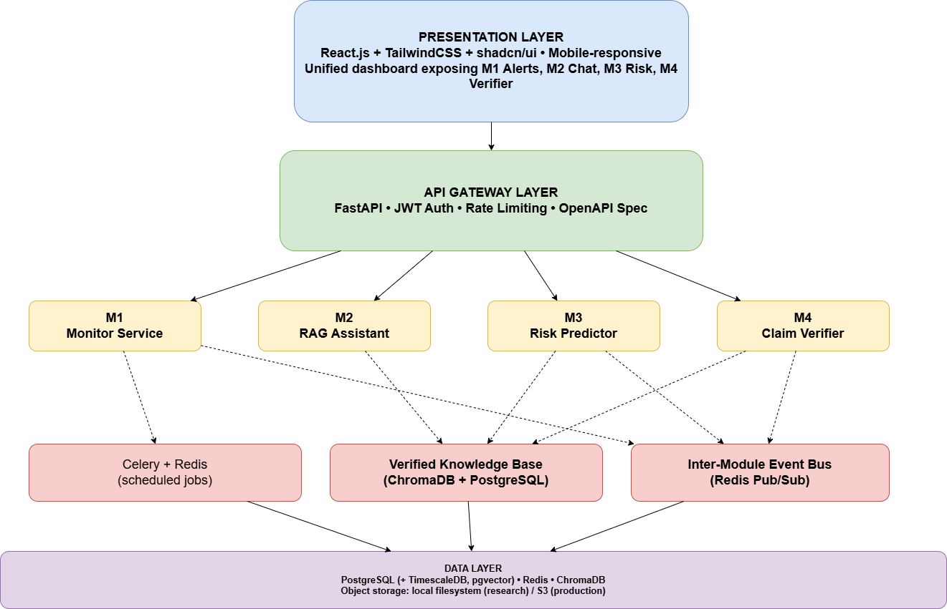
The presentation layer is a single React application rendering all four modules through a unified dashboard. The API gateway layer terminates authentication and routing. Each module is a separately deployable service (in the research prototype they share a process; in a future production deployment they could be independently scaled). Three shared infrastructure components — Celery for scheduled jobs, the verified knowledge base for ground truth, and the Redis-based event bus for cross-module triggers — bind the modules into a coherent platform. The data layer consolidates relational, vector, cache, and time-series storage on PostgreSQL (with extensions), Redis, and ChromaDB.

5.4 Module-Level Design

5.4.1 Module 1 Pipeline
Module 1 is structured as a five-stage pipeline executed by Celery workers on the configured schedule.
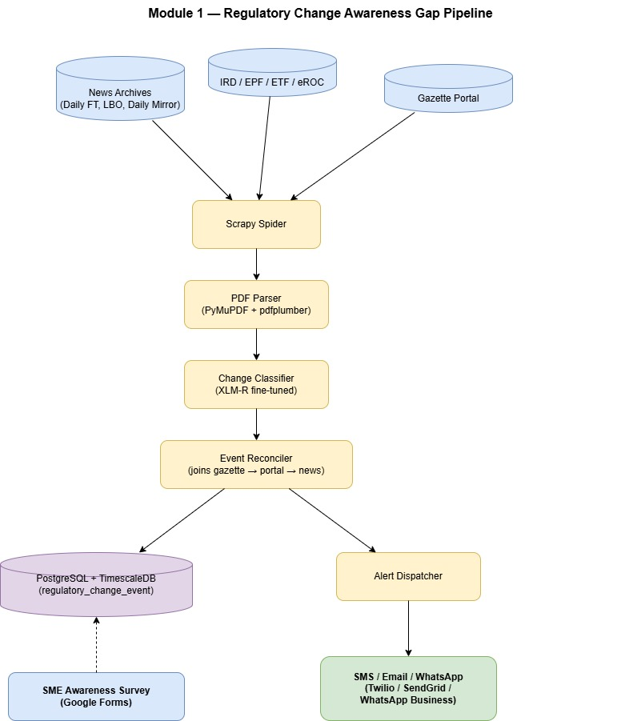

The Scrapy spider produces raw gazette records, the PDF Parser converts them to structured text with extracted dates and identifiers, the Change Classifier assigns a category, the Event Reconciler joins the gazette event with subsequent portal and news appearances to compute lag, and the Alert Dispatcher pushes notifications to subscribed SMEs. Survey-reported awareness times are merged into the same regulatory_change_event hypertable for offline lag analysis. The pipeline is idempotent — re-running a stage with the same input produces the same output, enabling safe retry on failure.

5.4.2 Module 2 Pipeline
Module 2 is split into an offline knowledge-base construction pipeline and an online query-answering pipeline.
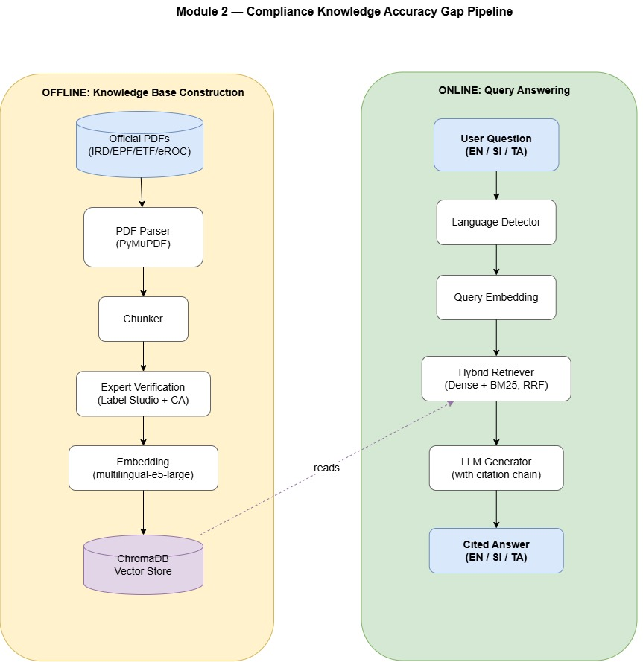
The offline pipeline runs whenever new official documents are added or existing ones revised. The online pipeline is invoked per user question through a FastAPI endpoint and returns within the NFR-1 latency budget. The same retriever serves Module 4's claim verification, with the verifier reading a verify=true flag that switches the LLM prompt from QA mode to verdict mode.

5.4.3 Module 3 Pipeline
Module 3 is a hybrid offline-training / online-scoring pipeline.
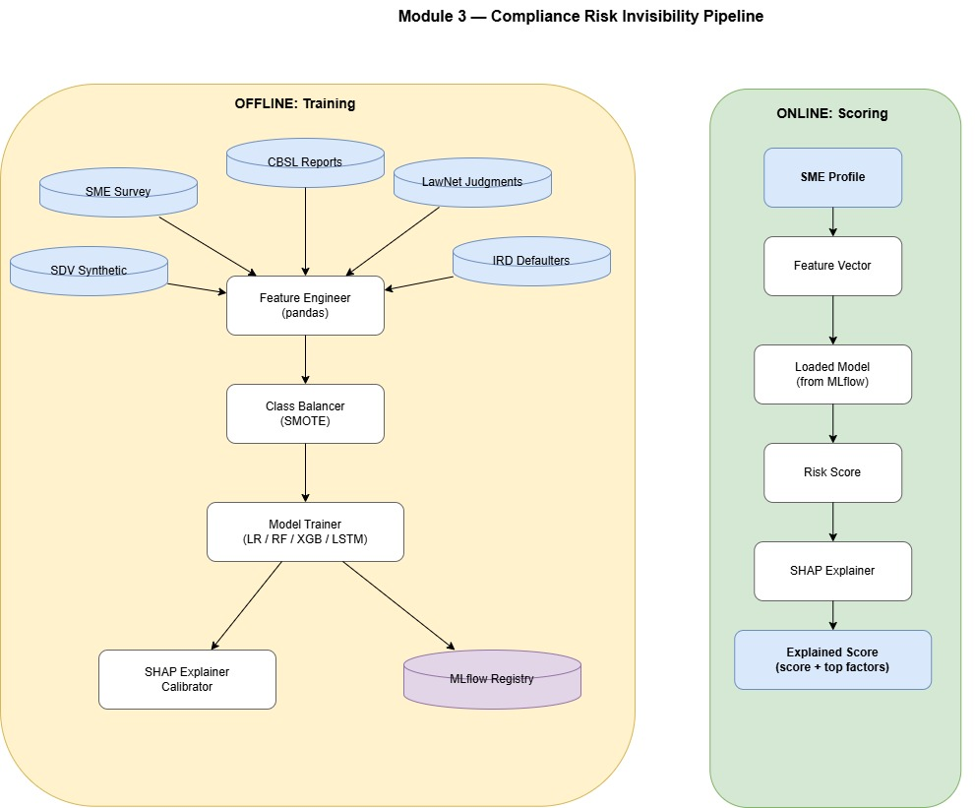
Model training is executed offline and the resulting artefacts are versioned in MLflow. Online scoring loads the latest registered model and serves predictions within the NFR-2 budget. When Module 1 publishes a regulatory-change event on the bus, Module 3 subscribes to relevant change types and triggers a batch rescoring of affected SMEs.

5.4.4 Module 4 Pipeline
Module 4 has both a research pipeline (corpus construction and analysis) and a production pipeline (real-time claim verification).

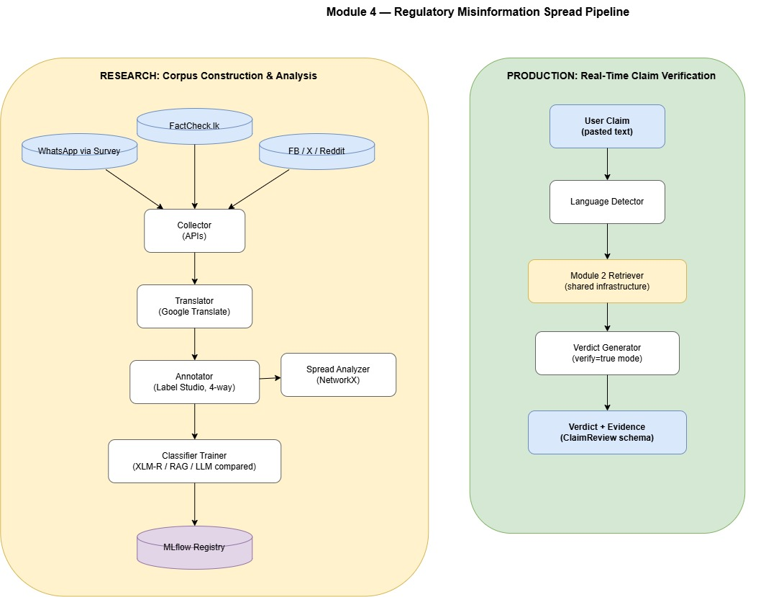
The research pipeline produces the annotated corpus and the trained classifier comparison; the production pipeline reuses Module 2's retriever and answers user-submitted claims in real time. The verdict generator returns a structured response conforming to the schema.org ClaimReview schema for future interoperability.

5.5 Data Flow Diagrams
The platform's data flow is presented at two levels. The Level 0 (context) diagram shows the platform as a single process exchanging data with external actors.
Figure 5.2 — Level 0 Data Flow Diagram

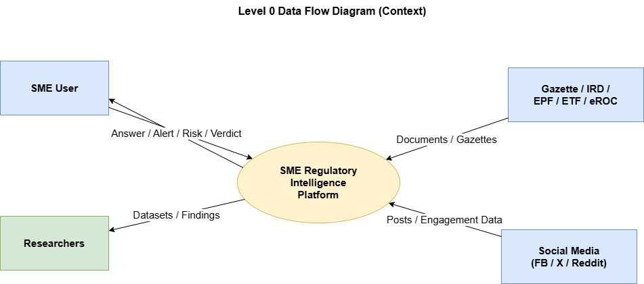
The Level 1 diagram decomposes the platform into the four modules and shows the principal data flows between them, with the verified knowledge base and the event bus as shared stores.
Figure 5.3 — Level 1 Data Flow Diagram
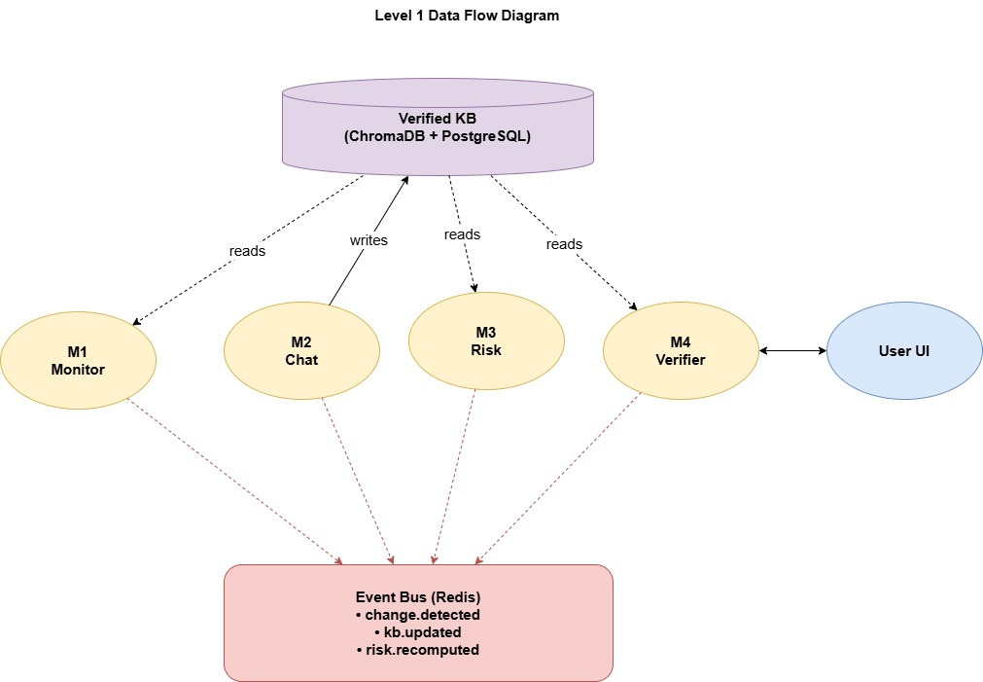

5.6 UML Diagrams

5.6.1 Domain Class Diagram
The core domain model is summarised below. Relationships use standard UML notation

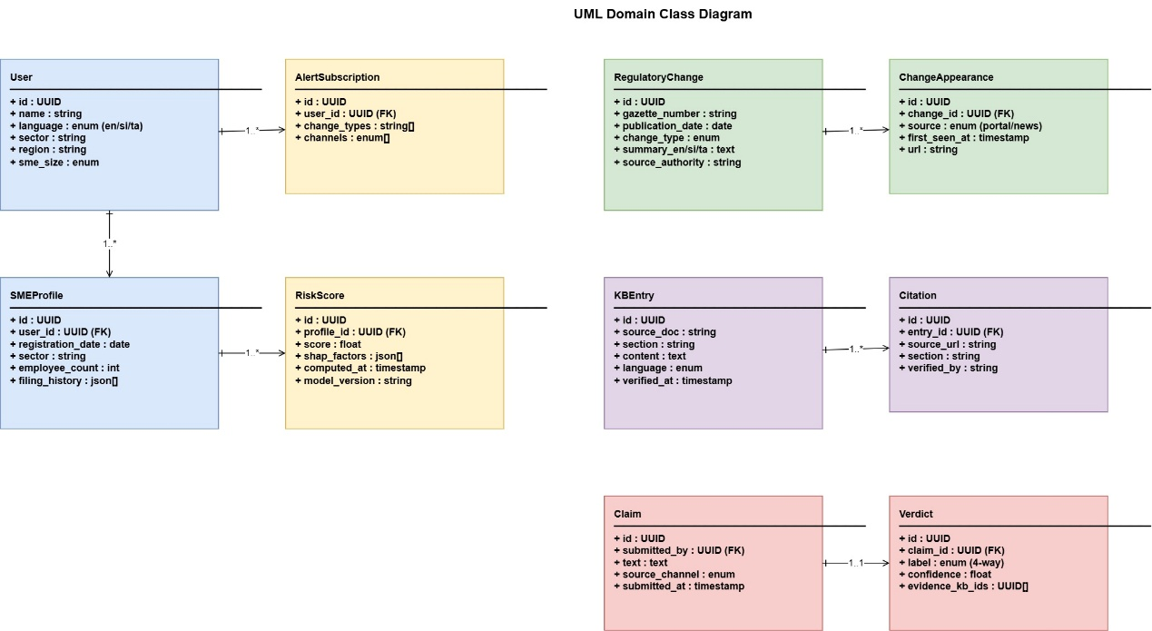

5.6.2 Sequence Diagram — End-to-End Compliance Question
The most representative cross-module interaction is a user submitting a compliance question. The sequence diagram below shows the request flow from React UI to RAG response, with the parallel risk-recomputation triggered by an inbound regulatory change.
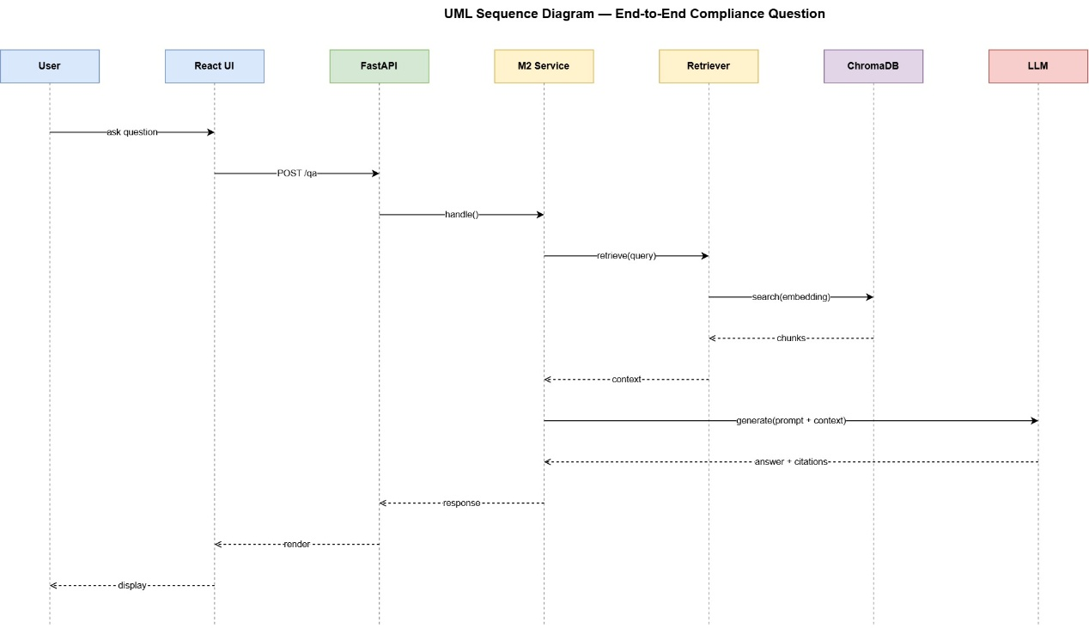
A second sequence covers the cross-module trigger: when Module 1 detects a regulatory change, it publishes change.detected on the bus, Module 2 subscribes to update the knowledge base, and Module 3 subscribes to recompute risk scores for affected SMEs.

5.7 Database Design
The relational schema in PostgreSQL is normalised to third normal form. The core tables and their key columns are summarised below.
Table 5.3 — Core Database Tables
Table | Purpose | Key Columns
users | Registered platform users | id, email, password_hash, language, created_at
sme_profiles | SME attributes for risk and personalisation | id, user_id, sector, employee_count, registration_date, region
alert_subscriptions | User preferences for alert delivery | id, user_id, change_types, channels (sms/email/whatsapp)
regulatory_changes | Hypertable of detected regulatory events | id, gazette_number, publication_date, change_type, summary_jsonb
change_appearances | Where and when each change was first seen | id, change_id, source, first_seen_at, url
awareness_responses | Survey-reported SME awareness timestamps | id, change_id, respondent_anon_id, awareness_date, channel
kb_entries | Verified knowledge base entries (metadata) | id, source_doc, section, language, content_hash, verified_at, verified_by
kb_chunks | Chunked content with embeddings stored in ChromaDB by id reference | id, kb_entry_id, chunk_text, chroma_id
risk_scores | Computed scores with full SHAP breakdown | id, profile_id, score, shap_factors_jsonb, model_version, computed_at
claims | User-submitted claims for verification | id, user_id, text, source_channel, submitted_at
verdicts | Verifier output with cited evidence | id, claim_id, label, confidence, evidence_kb_ids, generated_at
survey_responses | Anonymised compliance-knowledge survey responses | id, respondent_anon_id, question_id, answer, score, sector
The regulatory_changes table is configured as a TimescaleDB hypertable partitioned on publication_date, enabling efficient time-range queries for the lag analysis. ChromaDB stores embeddings keyed by chroma_id and is referenced from kb_chunks rather than embedded into PostgreSQL — keeping vector and relational concerns separated. Indexes are added on all foreign keys, on regulatory_changes.gazette_number, and on claims.submitted_at for efficient retrieval.

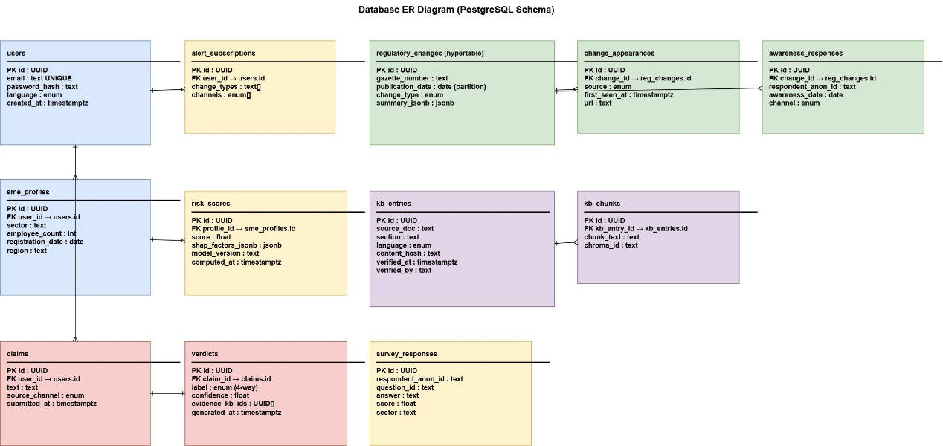

5.8 User Interface Design
The user interface is designed around a single dashboard rather than four separate tools, reflecting the platform's claim of unified intelligence
The design follows three principles. Language-first: a prominent language selector in the top bar applies to every component, including alerts and verdicts. Source citation everywhere: every answer, alert, and verdict shows its source. Mobile responsive: the four tiles collapse to a single column on mobile, ensuring SME owners on smartphones receive the same functionality. The component library is shadcn/ui over TailwindCSS, with all colours and typography defined as Tailwind tokens to support a future dark-mode and high-contrast variant.

5.9 Inter-Module Communication Design
Inter-module communication uses an event-driven publish/subscribe model on Redis Pub/Sub, with a small set of well-defined event types. Modules do not call one another's APIs directly; they publish events and subscribe to events of interest. This decoupling allows any module to be developed, tested, and deployed independently.
Table 5.4 — Inter-Module Events
Event | Publisher | Subscriber(s) | Payload
change.detected | M1 | M2, M3, M4 | change_id, change_type, gazette_number, publication_date
kb.updated | M2 | M4 | kb_entry_ids[], updated_at
risk.recomputed | M3 | UI (via WebSocket) | profile_id, new_score, delta
verdict.generated | M4 | (logging only) | claim_id, verdict_label, confidence
When change.detected fires, Module 2's KB ingestion job picks up the change, integrates the new regulation into the verified knowledge base after expert verification, and publishes kb.updated. Module 3's batch rescoring job picks up the same event and recomputes risk scores for SMEs whose profile features intersect with the change. Module 4 listens for kb.updated to refresh its retrieval cache, ensuring the verifier never operates on stale ground truth. WebSocket connections to the React UI propagate risk.recomputed events so users see updated scores in real time.
The event bus is intentionally simple. For the research prototype, Redis Pub/Sub is sufficient. A future production deployment could substitute Apache Kafka or NATS for guaranteed delivery and replay, without changing the publisher/subscriber contracts.

5.10 Summary
This chapter has presented the analysis and design of the SME Regulatory Intelligence Platform. Functional and non-functional requirements were enumerated and tagged for traceability through later chapters. The high-level architecture established a four-layer system with the four modules in the application layer, bound by a shared verified knowledge base and an event bus. Each module's pipeline was specified with sufficient detail to implement, and the offline/online split was made explicit where relevant. Data flow diagrams at Level 0 and Level 1, UML class and sequence diagrams, the database schema, the user interface design, and the inter-module event contract together form a complete blueprint for implementation. The next chapter documents the implementation of this design.

CHAPTER 06 - IMPLEMENTATION

6.1 Introduction
This chapter describes the planned implementation approach for the SME Regulatory Intelligence Platform. This chapter sets out how the implementation will be carried out: the development environment that will be standardized across the team, the planned construction sequence for each module, the integration strategy for binding the four modules into a unified platform, and representative pseudocode showing the structure of the most important components.
The implementation strategy will follow a vertical-slice incremental approach. Rather than building each module to completion sequentially, the team will build a thin end-to-end slice through every module first — a working scraper, a minimum viable knowledge base, a baseline classifier, a baseline risk model, and a working verifier — and will then iterate on each slice toward the full specification. This approach guarantees that the integration plumbing between modules is exercised early, that the platform can demonstrate end-to-end behavior at every milestone, and that integration risk is surfaced at the start of the project rather than at the end.

6.2 Development Environment and Setup
The development environment will be standardized across all four team members. Python 3.11 will serve as the runtime for all backend and ML code, with project dependencies pinned in a single requirements.txt and environment isolation through venv. Node.js 20 LTS will support the React frontend, with npm for faster installs and stricter dependency resolution. PostgreSQL 16 with the TimescaleDB and pgvector extensions will run locally via Docker Compose; the same Compose file will provision Redis 7, ChromaDB, and a Label Studio instance, allowing a new team member to bring up the entire stack with a single docker compose up command.
Source control will be managed on a private GitHub organisation under enigmatrix-uom/sme-regulatory-platform, with one branch per active feature and pull requests reviewed by at least one other team member before merging. Continuous integration will run on GitHub Actions: every push will trigger pytest for backend unit tests, eslint and vitest for frontend tests, and ruff + black for Python linting and formatting. Pre-commit hooks will enforce the same checks locally to keep CI fast. Experiment tracking for ML training runs will use MLflow on a self-hosted server within the university network, with run artefacts stored on the local filesystem.
Ethics approval will be obtained from the University of Moratuwa Faculty of Information Technology research committee before any survey distribution commences. Survey participants will be recruited through the Ceylon Chamber of Commerce, NEDA, and LinkedIn outreach, with informed consent captured electronically as the first page of every survey instrument.

6.3 Module 1 Implementation Progress

6.3.1 Gazette Scraper
The gazette scraper will be implemented as a Scrapy project with scrapy-playwright middleware to handle the JS-rendered listing pages on documents.gov.lk. The scraper will retrieve the gazette index, download each linked PDF, and store the file along with the publication date and gazette number in the regulatory_changes table. A separate spider will handle the IRD, EPF, ETF, and eROC notice pages; each will be implemented as a CrawlSpider subclass with site-specific link extractors.
A back-fill of the gazette archive from January 2018 onward will be performed once to seed the dataset, after which the scraper will run on an hourly schedule via a Celery beat task. Two engineering risks are anticipated. First, naive scraping is likely to trigger server-side throttling on government portals; this will be mitigated upfront by implementing a custom Scrapy DOWNLOADER_MIDDLEWARE that enforces a one-second minimum delay between requests to the same host, with exponential back-off on HTTP 429 responses. Second, gazette filename schemes are known to be inconsistent across years; this will be handled by a year-aware filename normaliser written after a brief survey of naming conventions across the archive.

6.3.2 Regulatory Change Classifier
Two classifier variants will be implemented and compared. A TF-IDF + Logistic Regression baseline will be trained on a hand-labelled set of gazette excerpts across approximately twelve change-type categories such as tax_rate_change, deadline_change, threshold_change, and procedural_amendment. Class imbalance is expected to be significant, with procedural amendments and tax-rate changes likely to dominate; this will be addressed using class-weighted loss.
A fine-tuned XLM-R classifier will then be trained on the same labelled set to test whether transformer-based classification meaningfully improves on the baseline — a comparison that is itself a research finding given the absence of any prior baseline for Sri Lankan regulatory text classification. Early stopping on validation loss will be configured to mitigate overfitting on the small initial training set. The labelled set will be expanded incrementally by team members through ongoing labelling sessions, with inter-annotator agreement spot-checked.

6.3.3 Lag Computation
The lag-computation logic will be implemented as a SQL view over the regulatory_changes, change_appearances, and awareness_responses tables, joined on change_id. The view will expose per-change lag durations at each transition (gazette → portal, portal → news, news → SME), plus an overall_lag column representing the gazette-to-SME-awareness duration. Awareness data will be collected through the SME survey distributed to a target sample of approximately 200 respondents.

6.4 Module 2 Implementation Progress

6.4.1 Knowledge Base Construction
The verified knowledge base will be structured as a Git-controlled repository of Markdown files with YAML front-matter, with one file per regulatory section (for example, kb/ird/income-tax/personal-relief.md). Each file will declare its source_doc, section, language, effective_date, and verified_by in the front-matter and contain the canonical text content. The ingestion pipeline will read this directory tree, chunk each file using a 512-token window with 64-token overlap, compute embeddings using multilingual-e5-large, and write both the chunks and the embeddings.
Expert verification will be performed by an external chartered accountant under a memorandum of understanding to be signed before knowledge-base construction begins. Entries will be routed to the accountant through Label Studio with a custom verification template that allows comments and corrections. The ingestion pipeline will be designed to be idempotent from the outset: re-running it after content changes will update only the affected entries by comparing content hashes, avoiding the cost of re-embedding the entire corpus on every run.

6.4.2 RAG Pipeline
The RAG pipeline will be implemented in LangChain following the design in Section 5.4.2. The hybrid retriever will combine dense embedding similarity (via the same multilingual-e5-large model used for ingestion) with BM25 lexical search over the chunk text, fused using reciprocal rank fusion with k=60. Retrieved context will be passed to the LLM along with a system prompt that mandates citation of source authorities and refuses to answer when the retrieved context does not adequately cover the question.
The LLM backbone will be a hosted commercial LLM (such as Claude or GPT-4) for the prototype, with Llama 3 8B Instruct configured as the open-source alternative for the reproducibility benchmark planned for the final report. The chain will return answers with structured citations conforming to LangChain's RetrievalQAWithSourcesChain output, and these citations will be rendered inline in the React UI as clickable links to the source document section.
Evaluation will use the RAGAS framework, measuring faithfulness, answer relevancy, context precision, and context recall on a held-out test set drawn from the survey questions. Hyperparameter tuning experiments will be conducted on chunk size (256, 512, 1024 tokens) and number of retrieved chunks (k = 4, 6, 8) to find the configuration that maximises faithfulness while maintaining adequate context recall.

6.4.3 Compliance Knowledge Survey
The compliance knowledge survey will be deployed as a Google Form with branching by SME registration status (VAT-registered vs not, employer vs sole-trader) to ensure every respondent receives only relevant questions. The survey will contain 40–50 verifiable questions across five domains: VAT, income tax, EPF/ETF, SSCL, and corporate filings. Each question will have a single correct answer that can be objectively scored against the verified knowledge base. The target sample is approximately 100 valid responses.
A scoring engine will be implemented in Python to produce per-respondent and per-domain accuracy scores. The aggregate accuracy will become the empirical baseline of informal-channel and self-knowledge accuracy against which the RAG assistant must improve.

6.5 Module 3 Implementation Progress

6.5.1 Dataset Assembly
Five data sources will be combined into a unified labelled dataset. The IRD published defaulter list will be scraped and deduplicated with entity resolution (matching corporate name variants such as "(Pvt) Ltd" vs "(Private) Limited"). LawNet judgment records will be scraped and parsed to extract structured outcomes (violation type, fine amount, business sector). CBSL annual reports will be parsed to extract sector-level financial-health indicators over time. The SME vulnerability survey will collect self-reported compliance failures with rich contextual features. Finally, synthetic SME profiles will be generated using SDV's CTGAN model and calibrated against Department of Census and Statistics SME population marginals (sector × employee-count band × region), with calibration verified by chi-square tests against the public statistics.
The unified dataset is expected to exhibit a heavy class imbalance between violators and non-violators, which the modelling stage will address.

6.5.2 Model Training and Comparison
Four model classes will be trained and compared, all registered in MLflow for reproducibility. Logistic Regression will provide an interpretable baseline. Random Forest and XGBoost will provide strong tabular alternatives, with XGBoost hyperparameters tuned via optuna. An LSTM ingesting per-SME filing-history sequences will provide the temporal model needed to answer the lead-time research question.
Class imbalance will be addressed in two stages. First, class-weighted loss functions will be tried as the lightest-touch intervention. Where weighting alone proves insufficient, SMOTE oversampling will be applied at the feature-engineering stage, with Borderline-SMOTE and SMOTEENN held in reserve as variants. The temporal lead-time analysis will evaluate predictive performance at 1-, 3-, and 6-month horizons before each historical violation, answering the research question of how early a signal becomes detectable. Retrospective validation will hold out the most recent year of IRD defaulter records and measure the model's ability to identify those defaulters from their pre-violation profiles.

6.5.3 Explainability Layer
The explainability layer will use SHAP, with TreeExplainer for the tree models and DeepExplainer for the LSTM. The risk-scoring API endpoint will return both the numerical score and the top contributing features with their SHAP values, formatted as a structured JSON response that the React UI will render as a horizontal bar chart with risk-increasing and risk-decreasing factors visually distinguished. This explainability layer is not optional — it is the mechanism by which the platform converts an opaque score into actionable guidance for the SME.
6.6 Module 4 Implementation Progress

6.6.1 Social Media Collection
Collection will proceed exclusively through compliant API channels. Reddit will be collected via PRAW from r/srilanka and related subreddits, filtered to posts mentioning regulatory keywords. Facebook will be collected via the Meta Graph API from named public groups focused on Sri Lankan business and tax topics. X (Twitter) will be collected via the X API v2 under the Academic Research access tier, for which the team will apply early in the project. WhatsApp content, given its end-to-end-encrypted private nature, will be collected exclusively through user-submitted forwards via the survey instrument with explicit consent — there is no API option, and no scraping route would be either legal or possible. FactCheck.lk will be scraped to provide a high-quality seed of pre-labelled regulatory claims.

6.6.2 Annotation Workflow
Label Studio will be configured with a four-way label schema (accurate / partially accurate / misleading / false). At least three annotators will participate: two team members and one external native-Sinhala-speaking volunteer, with a fourth Tamil-speaking annotator to be recruited. Annotation guidelines will be drafted before annotation begins and refined based on early disagreement patterns, particularly around the harder middle categories.
A double-annotated 20% subset will be used to compute Cohen's Kappa (and Krippendorff's Alpha where three annotators participate). Annotation will only proceed at scale once agreement clears 0.7.

6.6.3 Misinformation Classifier
Three classifier variants will be trained and compared on the same held-out test split. The fine-tuned XLM-R will be the primary classifier, consistent with the platform's transformer choice and supported by published evidence on multilingual misinformation. A RAG-based verification variant will reuse the Module 2 knowledge base and retrieval pipeline, testing the hypothesis that grounding outperforms fine-tuning on regulatory claims — a comparison that is itself a research finding because it speaks directly to the data efficiency of the two approaches. A hosted-LLM variant (such as Claude or GPT-4 with a structured verification prompt) will provide the upper-bound baseline against which the open-source results are interpreted.
The three variants will be evaluated using per-class F1, precision, and recall, with statistical significance tested between the best and second-best variants.

6.7 Platform Integration Progress
The vertical-slice integration target is to have a working end-to-end demonstration by the end of the first development sprint. The FastAPI backend will expose endpoints for all four modules, the React frontend will render the unified dashboard described in Section 5.8, and JWT-based authentication will protect the routes. End-to-end behaviour to be demonstrated includes: a user registering, configuring their language and sector preference, viewing the latest gazette-detected alerts, asking a compliance question and receiving a cited answer, viewing their risk score with SHAP explanations, and submitting a claim for verification.
The Redis Pub/Sub event bus will be wired in early to exercise cross-module triggers from the start. An integration test will be written that injects a synthetic regulatory-change event into the bus and verifies downstream knowledge-base update, risk recomputation, and verifier readiness — providing automated assurance that the cross-module triggers behave as designed. WebSocket propagation of risk.recomputed events to the React UI will allow users to see updated scores in real time.
The alert dispatch channels will be implemented in priority order: email via SendGrid first (lowest friction), WhatsApp via the Meta WhatsApp Business API second (requires Meta business-account verification, planned to be initiated early to absorb the verification lead time), and SMS via Twilio third behind a feature flag pending budget approval for production-scale messaging during the user evaluation phase.

6.8 Pseudocode and Code Segments
This section provides representative pseudocode showing the planned structure of the most consequential parts of the implementation.
Listing 6.1 — Hourly gazette polling and parsing (Module 1)
TASK

gazette_polling_hourly:
new_pdfs = scrapy_spider.fetch_new_gazettes(
portal_url = GAZETTE_URL,
since = max(publication_date) FROM regulatory_changes,
rate_limit = 1 request / second
)
FOR each pdf IN new_pdfs:
text = pymupdf.extract_text(pdf)
meta = extract_metadata(text) # gazette_no, pub_date
excerpts = split_into_change_excerpts(text)
FOR each excerpt IN excerpts:
change_type = xlmr_classifier.predict(excerpt)
change_record = persist(regulatory_changes,
gazette_no, pub_date,
change_type, summary)
event_bus.publish("change.detected", change_record.id)
LOG completion_metrics

Listing 6.2 — Hybrid retrieval and answer generation (Module 2)
Python
def answer(question: str, language: str) -> Answer:
# 1) detect language and translate to canonical English if needed
canonical_q = translate(question, source=language, target="en") \
if language != "en" else question
# 2) hybrid retrieval — dense + BM25, fused via RRF
dense_hits = chroma.similarity_search(embed(canonical_q), k=10)
sparse_hits = bm25.search(canonical_q, k=10)
fused = reciprocal_rank_fusion(dense_hits, sparse_hits, k_const=60)
context = fused[:6] # top 6 chunks after fusion
# 3) refuse if context is too thin
if max(c.score for c in context) < CONFIDENCE_THRESHOLD:
return Answer(text=REFUSAL_MESSAGE, citations=[])
# 4) generate answer with citations
llm_response = llm.generate(
prompt=COMPLIANCE_PROMPT.format(question=canonical_q, context=context),
require_citations=True
)
# 5) translate answer back if needed and return
final_text = translate(llm_response.text, source="en", target=language) \
if language != "en" else llm_response.text
return Answer(text=final_text, citations=llm_response.citations)

Listing 6.3 — Risk scoring with SHAP explanation (Module 3)
Python
def score_risk(profile: SMEProfile) -> ExplainedScore:
# 1) build feature vector
x = feature_engineer.transform(profile)
# 2) load currently registered model from MLflow
model = mlflow.load_model(name="sme_risk_xgb", stage="Production")
# 3) predict risk probability
risk_prob = model.predict_proba(x)[0][1] # probability of violation
# 4) compute SHAP explanation
shap_values = tree_explainer.shap_values(x)
top_factors = sorted(
zip(feature_names, shap_values[0]),
key=lambda kv: abs(kv[1]),
reverse=True
)[:5]
# 5) persist and return
record = persist(risk_scores,
profile_id = profile.id,
score = risk_prob,
shap_factors = top_factors,
model_version = model.version)
return ExplainedScore(score=risk_prob, factors=top_factors)

Listing 6.4 — Claim verification reusing Module 2 retriever (Module 4)
Python
def verify_claim(claim_text: str) -> Verdict:
# 1) extract canonical claim form (translate, normalise)
canonical = preprocess(claim_text)
# 2) reuse Module 2's hybrid retriever in verify mode
evidence = hybrid_retriever.retrieve(canonical, k=6)
# 3) classify the claim against the evidence using the verifier prompt
verdict = llm.generate(
prompt=VERIFICATION_PROMPT.format(claim=canonical, evidence=evidence),
output_schema=ClaimReviewSchema # accurate / partially / misleading / false
)
# 4) persist and emit event
record = persist(verdicts,
claim_id = canonical.claim_id,
label = verdict.label,
confidence = verdict.confidence,
evidence_kb_ids = [e.id for e in evidence])
event_bus.publish("verdict.generated", record.id)
return Verdict(**verdict.dict())

Listing 6.5 — Cross-module event handler illustrating the integration plumbing
python
@event_bus.subscriber("change.detected")
def on_change_detected(change_id: UUID):
change = db.get(RegulatoryChange, change_id)
# M2 — refresh knowledge base if the change is a known KB topic
if change.change_type in KB_TRACKED_TYPES:
kb_ingestor.upsert_from_change(change)
event_bus.publish("kb.updated", [change_id])
# M3 — recompute risk for SMEs whose features intersect the change
affected = sme_profiles.find_intersecting(change)
for profile in affected:
new_score = risk_scorer.score_risk(profile)
event_bus.publish("risk.recomputed", profile.id, new_score)

6.9 Summary
This chapter has set out the implementation plan for the SME Regulatory Intelligence Platform. The development environment will be standardised through Docker Compose, Python 3.11, Node 20 LTS, and a shared GitHub repository with CI on every push. Each of the four modules has a defined construction sequence: Module 1 will build the gazette scraper, change classifier, and lag-computation pipeline; Module 2 will build the verified knowledge base, hybrid-retrieval RAG pipeline, and compliance-knowledge survey; Module 3 will assemble the unified labelled dataset, train and compare four model classes, and add a SHAP-based explainability layer; Module 4 will collect social-media content through compliant APIs, build an annotated misinformation corpus through Label Studio, and compare three classifier variants. The vertical-slice integration approach will exercise the cross-module event bus from the first sprint, surfacing integration risk early. Representative pseudocode in Section 6.8 illustrates the structure planned for the most consequential components. The next chapter sets out the evaluation methodology and the criteria against which each module's solution will be validated against its measured baseline.

CHAPTER 07 - DISCUSSION

7.1 Introduction

7.2 Preliminary Results and Observations

7.3 Comparison with Similar Works

7.4 Limitations and Risks

7.4.1 Data Availability Risks

7.4.2 Survey Response Risks

7.4.3 Model Generalization Risks

7.5 Ethical Considerations

7.5.1 Privacy and Anonymisation

7.5.2 Bias and Fairness

7.5.3 Security and Data Handling

7.5.4 Ethics Approval Status

7.6 Plan for Evaluation

7.6.1 Evaluation Metrics per Module

7.6.2 Validation against Research Findings

7.7 Future Work

7.8 Summary

REFERENCES
[1] Friedrich Naumann Foundation, "SME in Sri Lanka: Small and Medium-sized Enterprises (SMEs) of Sri Lanka," 2024. [Online]. Available: https://www.freiheit.org/south-asia/small-and-medium-sized-enterprises-smes-sri-lanka
[2] T. Wickramasinghe, "Developing MSMEs in the present context of Sri Lanka," The Morning, June 11, 2025. [Online]. Available: https://www.themorning.lk/articles/mzG2fW0S2z3pMqurApAT
[3] Inland Revenue Department of Sri Lanka, "Type of Taxes - Social Security Contribution Levy (SSCL)," 2023. [Online]. Available: https://www.ird.gov.lk/en/Type%20of%20Taxes/SitePages/Social%20Security%20Contribution%20Levy%20(SSCL).aspx
[4] O. Akinwale and M. Simpa, "Navigating Financial Compliance in Small and Medium-Sized Enterprises: Challenges and Strategies," World Journal of Advanced Research and Reviews, 2024. [Online]. Available: https://wjarr.com/sites/default/files/WJARR-2024-1984.pdf
[5] N. de Silva, "BERTifying Sinhala - A Comprehensive Analysis of Pre-trained Language Models for Sinhala Text Classification," in Proc. LREC 2022, pp. 7377-7385. [Online]. Available: https://aclanthology.org/2022.lrec-1.803.pdf
[6] Advocata Institute, "Is Sri Lanka keeping its small businesses small?" The Sunday Morning Business, Oct. 31, 2019. [Online]. Available: https://www.advocata.org/commentary-archives/2019/10/31/is-sri-lanka-keeping-its-small-businesses-small
[7] OECD, Improving the Business Environment for SMEs Through Effective Regulation, Policy Note, 2018 SME Ministerial Conference, OECD, 2018.
[8] KPMG Sri Lanka, "Tax Alert - Social Security Contribution Levy," June 2022. [Online]. Available: https://assets.kpmg.com/content/dam/kpmg/lk/pdf/kpmg-tax-news/june-2022/kpmg-srilanka-tax-alert-social-security-contribution-levy-june-23-2022.pdf
[9] Ministry of Finance, Sri Lanka, "Budget Proposals 2022," Government of Sri Lanka. [Online]. Available: https://www.treasury.gov.lk/web/budget-proposal
[10] H. Yuwono et al., "Regulatory and Policy Barriers to SMEs' E-Commerce Adoption in Developing Countries," ResearchGate Preprint, 2025. [Online]. Available: https://www.researchgate.net/publication/398836701
[11] D. W. Arner, J. Barberis, and R. P. Buckley, "FinTech, RegTech, and the Reconceptualization of Financial Regulation," Northwestern Journal of International Law & Business, vol. 37, pp. 371-414, 2016.
[12] N. Bussmann, P. Giudici, D. Marinelli, and J. Papenbrock, "Explainable Machine Learning in Credit Risk Management," Computational Economics, vol. 57, pp. 203-216, 2021. [Online]. Available: https://doi.org/10.1007/s10614-020-10042-0
[13] G. P. Nobre, C. H. G. Ferreira, and J. M. Almeida, "A Hierarchical Network-Oriented Analysis of User Participation in Misinformation Spread on WhatsApp," arXiv preprint, arXiv:2109.10462, 2021. [Online]. Available: https://arxiv.org/pdf/2109.10462
[14] S. Balakrishnan et al., "Antecedents and Consequences of Misinformation Sharing Behavior among Adults on Social Media during COVID-19," Frontiers in Psychology, 2022. [Online]. Available: https://www.ncbi.nlm.nih.gov/pmc/articles/PMC9852977/
[15] S. M. Lundberg and S.-I. Lee, "A Unified Approach to Interpreting Model Predictions," in Proc. 31st Conf. Neural Information Processing Systems (NeurIPS), 2017, pp. 4765-4774.
[16] McKinsey & Company, "What is RegTech?" McKinsey Explainers, Aug. 11, 2025. [Online]. Available: https://www.mckinsey.com/featured-insights/mckinsey-explainers/what-is-regtech
[17] P. Lewis et al., "Retrieval-Augmented Generation for Knowledge-Intensive NLP Tasks," in Proc. NeurIPS 2020, pp. 9459-9474.
[18] N. Wiratunga et al., "CBR-RAG: Case-Based Reasoning for Retrieval Augmented Generation in LLMs for Legal Question Answering," arXiv preprint, arXiv:2404.04302, 2024. [Online]. Available: https://arxiv.org/pdf/2404.04302
[19] A. Conneau et al., "Unsupervised Cross-lingual Representation Learning at Scale," in Proc. ACL 2020, pp. 8440-8451.
[20] D. Butler and L. O'Brien, "Understanding RegTech for Digital Regulatory Compliance," in Disrupting Finance, T. Lynn et al., Eds. Cham: Palgrave Macmillan, 2019, pp. 85-102. [Online]. Available: https://link.springer.com/chapter/10.1007/978-3-030-02330-0_6
[21] T. V. Vu, T. T. Pham, T. T. T. Nguyen, A. T. Nguyen, and H. T. Nguyen, "SME financing role in developing business environment and economic growth: empirical evidences from technical SMEs in Vietnam," Environmental Science and Pollution Research, vol. 29, pp. 53540-53552, 2022. [Online]. Available: https://pmc.ncbi.nlm.nih.gov/articles/PMC8919356/
[22] D. Musimenta, "Knowledge requirements, tax complexity, compliance costs and tax compliance in Uganda," Cogent Business & Management, vol. 7, no. 1, 2020, Art. no. 1812220.
[23] R. R. Agusti and A. F. Rahman, "Determinants of tax attitude in small and medium enterprises: Evidence from Indonesia," Cogent Business & Management, vol. 10, no. 1, 2023, Art. no. 2160585.
[24] T. Mokoena, "Voluntary tax compliance determinants among small and medium enterprises in democratic societies: the role of tax literacy, tax amnesty, tax reward, and service delivery," Cogent Business & Management, vol. 12, no. 1, 2025. [Online]. Available: https://www.tandfonline.com/doi/full/10.1080/23311975.2025.2526139
[25] E. Kirchler, E. Hoelzl, and I. Wahl, "Enforced versus voluntary tax compliance: The 'slippery slope' framework," Journal of Economic Psychology, vol. 29, no. 2, pp. 210-225, 2008.
[26] G. A. Akerlof, "The Market for 'Lemons': Quality Uncertainty and the Market Mechanism," Quarterly Journal of Economics, vol. 84, no. 3, pp. 488-500, 1970.
[27] D. Light, "Pharmaceuticals as a market for 'lemons': Theory and practice," Social Science & Medicine, vol. 268, 2021, Art. no. 113503. [Online]. Available: https://pubmed.ncbi.nlm.nih.gov/32979775/
[28] R. Long, "The Market for Lemons and the Regulator's Signalling Problem," arXiv preprint, arXiv:2312.10896, 2023. [Online]. Available: https://arxiv.org/abs/2312.10896
[29] L. Wang and Y. Chen, "The Role of ESG Information Disclosure in Reducing Information Asymmetry: Evidence from SMEs," Madison Proceedings - AEMR, 2024. [Online]. Available: https://madison-proceedings.com/index.php/aemr/article/download/4131/4146
[30] A. Banerjee, "Automating Regulatory Compliance with NLP: From Manual Monitoring to Near-Real-Time Intelligence," LinkedIn Pulse, Feb. 2026. [Online]. Available: https://www.linkedin.com/pulse/automating-regulatory-compliance-nlp-from-manual-abhik-banerjee-mba-wjikc
[31] O. Adeyemi, "Leveraging natural language processing for automated regulatory compliance in financial reporting," ResearchGate Preprint, 2025. [Online]. Available: https://www.researchgate.net/publication/393166928
[32] Elder Research, "Natural Language Processing for RegTech: Uncovering Hidden Patterns in Regulatory Documents," 2020. [Online]. Available: https://www.elderresearch.com/blog/natural-language-processing-for-regtech-uncovering-hidden-patterns-in-regulatory-documents/
[33] T. Gokhan et al., "RegNLP in Action: Facilitating Compliance Through Automated Information Retrieval and Answer Generation," arXiv preprint, arXiv:2409.05677, 2024. [Online]. Available: https://arxiv.org/html/2409.05677v1
[34] WHO, "Social media and the spread of misinformation: infectious and a threat to public health," Health Promotion International, vol. 40, no. 2, 2025, Art. no. daaf023. [Online]. Available: https://academic.oup.com/heapro/article/40/2/daaf023/8100645
[35] V. Balakrishnan, W. Z. Ng, and M. C. Soo, "Antecedents and Consequences of Misinformation Sharing Behavior among Adults on Social Media during COVID-19," International Journal of Environmental Research and Public Health, 2022. [Online]. Available: https://www.ncbi.nlm.nih.gov/pmc/articles/PMC9852977/
[36] L. Bonifazi et al., "Look Who's Talking: Interpretable Machine Learning for Assessing Italian SMEs Credit Default," arXiv preprint, arXiv:2108.13914, 2021. [Online]. Available: https://arxiv.org/pdf/2108.13914
[37] T. Albalawi and S. Dardouri, "Enhancing credit card fraud detection using traditional and deep learning models with class imbalance mitigation," Frontiers in Artificial Intelligence, vol. 8, 2025, Art. no. 1643292. [Online]. Available: https://www.ncbi.nlm.nih.gov/pmc/articles/PMC12540476/
[38] S. J. Miah et al., "Extending application of explainable artificial intelligence for managers in financial organizations," Annals of Operations Research, 2024. [Online]. Available: https://link.springer.com/article/10.1007/s10479-024-05825-9
[39] J. Yeo et al., "SHAP Stability in Credit Risk Management: A Case Study in Credit Card Default Model," Risks, vol. 13, no. 12, 2025, Art. no. 238. [Online]. Available: https://www.mdpi.com/2227-9091/13/12/238
[40] N. V. Chawla, K. W. Bowyer, L. O. Hall, and W. P. Kegelmeyer, "SMOTE: Synthetic Minority Over-sampling Technique," Journal of Artificial Intelligence Research, vol. 16, pp. 321-357, 2002.
[41] M. Isangediok and K. Gajamannage, "Fraud Detection Using Optimized Machine Learning Tools Under Imbalance Classes," arXiv preprint, arXiv:2209.01642, 2022. [Online]. Available: https://arxiv.org/pdf/2209.01642
[42] J. Smith and L. Brown, "Fraud Detection System for Banking Transactions," arXiv preprint, arXiv:2604.07952, 2026. [Online]. Available: https://arxiv.org/pdf/2604.07952
[43] J. Devlin, M.-W. Chang, K. Lee, and K. Toutanova, "BERT: Pre-training of Deep Bidirectional Transformers for Language Understanding," in Proc. NAACL-HLT 2019, pp. 4171-4186.
[44] M. Choras et al., "Lifelong Learning Natural Language Processing Approach for Multilingual Data Classification," arXiv preprint, arXiv:2206.11867, 2022. [Online]. Available: https://arxiv.org/pdf/2206.11867
[45] J. Singh, "PolyTruth: Multilingual Disinformation Detection using Transformer-Based Language Models," arXiv preprint, arXiv:2509.10737, 2025. [Online]. Available: https://arxiv.org/pdf/2509.10737
[46] X. Wang et al., "FinSage: A Multi-aspect RAG System for Financial Filings Question Answering," arXiv preprint, arXiv:2504.14493, 2025. [Online]. Available: https://arxiv.org/pdf/2504.14493
[47] D. Sandaruwan et al., "Enhancing Multilingual Sentiment Analysis with Explainability for Sinhala, English, and Code-Mixed Content," arXiv preprint, arXiv:2504.13545, 2025. [Online]. Available: https://arxiv.org/pdf/2504.13545
[48] S. Wijesiri et al., "Keyword Extraction, and Aspect Classification in Sinhala, English, and Code-Mixed Content," arXiv preprint, arXiv:2504.10679, 2025. [Online]. Available: https://arxiv.org/abs/2504.10679
[49] D. Polonskaia, "DN at SemEval-2023 Task 12: Low-Resource Language Text Classification via Multilingual Pretrained Language Model Fine-tuning," arXiv preprint, arXiv:2305.02607, 2023. [Online]. Available: https://arxiv.org/pdf/2305.02607
[50] H. El Asri et al., "Retrieval-Augmented Generation for Reliable Interpretation of Radio Regulations," arXiv preprint, arXiv:2509.09651, 2025. [Online]. Available: https://arxiv.org/html/2509.09651v1
[51] Y. Xi et al., "Hybrid Retrieval-Augmented Generation Agent for Trustworthy Legal Question Answering in Judicial Forensics," arXiv preprint, arXiv:2511.01668, 2025. [Online]. Available: https://arxiv.org/abs/2511.01668
[52] S. Es, J. James, L. Espinosa-Anke, and S. Schockaert, "RAGAS: Automated Evaluation of Retrieval Augmented Generation," arXiv preprint, arXiv:2309.15217, 2023. [Online]. Available: https://arxiv.org/abs/2309.15217
[53] J. Saad-Falcon et al., "ARES: An Automated Evaluation Framework for Retrieval-Augmented Generation Systems," arXiv preprint, arXiv:2311.09476, 2023. [Online]. Available: https://arxiv.org/pdf/2311.09476
[54] T. Ding et al., "VERA: Validation and Evaluation of Retrieval-Augmented Systems," arXiv preprint, arXiv:2409.03759, 2024. [Online]. Available: https://arxiv.org/pdf/2409.03759
[55] Y. Zhou et al., "Trustworthiness in Retrieval-Augmented Generation Systems: A Survey," arXiv preprint, arXiv:2409.10102, 2024. [Online]. Available: https://arxiv.org/pdf/2409.10102

Appendix A - Individual's Contribution to the Project

A.1 215075J - Mohamed M.R.I

A.2 215007F - Ahamadh M.S.A

A.3 215008J - Ahamed T.I

A.4 215019T - Cader Z.R

Appendix B - Survey Instruments

Appendix C - Sample Annotated Data

Appendix D - Code Listings and Algorithms

Appendix E - Detailed Architecture Diagrams

Appendix F - Ethics Approval Documentation

